Contents

AI, ML AND DEEP LEARNING 4

TYPES OF AI 6

COMPONENTS OF AI 6

HISTORY OF AI 7

WHAT IS MACHINE LEARNING 8

MACHINE LEARNING TERMINOLOGIES 9

DEEP LEARNING 10

ADVANTAGES OF DEEP LEARNING 11

REINFORCEMENT LEARNING 11

GENERATIVE AI 12

NLP(NATURAL LANGUAGE PROCESSING) 12

CONVENTIONAL (PREDICTIVE) AI VERSUS GENERATIVE AI 14

MACHINE LEARNING MODEL 15

MACHINE LEARNING PROCESS 16

MACHINE LEARNING MODEL AND DATASET 17

DATA SET 17

TRAINING SET AND TEST SET 18

FEATURES AND LABELS 20

GENERATIVE AI – IN DETAILS 21

GENERATIVE AI VS DISCRIMINATIVE AI 22

LARGE LANGUAGE MODELS(LLMs) 24

BENEFITS OF LLMS 24

HOW LLMS WORK 25

MODEL TYPES (LLM TYPES) 29

EMBEDDINGS IN GENERATIVE AI 31

FINE TUNING 32

DEEP LEARNING ARCHITECTURE 34

DIFFERENT ARCHITECTURE OF DEEP LEARNING 35

RECURRENT NEURAL NETWORKS (RNNS) 35

CONVOLUTIONAL NEURAL NETWORKS (CNNS) 35

TRANSFORMER ARCHITECTURE 35

FOUNDATION MODEL 37

KEY CHARACTERISTICS 37

APPLICATION OF GEN-AI 38

GEN-AI USE CASES 39

GEN-AI LIMITATIONS & CHALLENGES 39

FEATURE SCALING 40

NORMALIZATION 41

STANDARDIZATION 42

EXAMPLE - NORMALIZATION 42

TRAINING ML MODELS 43

LIFECYCLE 43

FEATURE ENGINEERING 44

TYPES OF ML MODELS 44

TRADITIONAL MACHINE LEARNING MODELS 44

REPRESENTATIONAL (OR REPRESENTATION LEARNING) MODELS 44

CHOOSING THE RIGHT ML SOLUTION 44

TYPES OF MACHINE LEARNING 45

SUPERVISED LEARNING 46

CLASSIFICATION (BINARY CLASSIFICATION) 48

REGRESSION ALGORITHM 50

UNSUPERVISED LEARNING 52

SUPERVISED V/S UN-SUPERVISED LEARNING 53

SPECIALIZED ML PROBLEMS 53

RECOMMENDATION SYSTEMS 54

TYPES OF RECOMMENDATION SYSTEMS 54

ASSOCIATIONS RULES DETECTION 56

REINFORCEMENT LEARNING 57

APPLYING ML IN COMPLEX DATA 58

APPLYING ML TO TEXT DATA 58

ENCODING TECHNIQUES 59

APPLYING ML TO IMAGE DATA 61

APPLYING ML TO SPEECH DATA 61

MACHINE LEARNING ALGORITHMS CLASSIFICATION 61

ANOMALY DETECTION ALGORITHM 61

CLUSTERING ALGORITHM 61

DATA PRE-PROCESSING USING PYTHON 62

DATA PROCESSING USING PYTHON 67

REGRESSION 67

SIMPLE LINEAR REGRESSION 67

MULTIPLE LINEAR REGRESSION 68

POLYNOMIAL REGRESSION 68

SUPPORT VECTOR REGRESSION 68

DECISION TREE REGRESSION 68

RANDOM FOREST REGRESSION 68

# AI, ML AND DEEP LEARNING

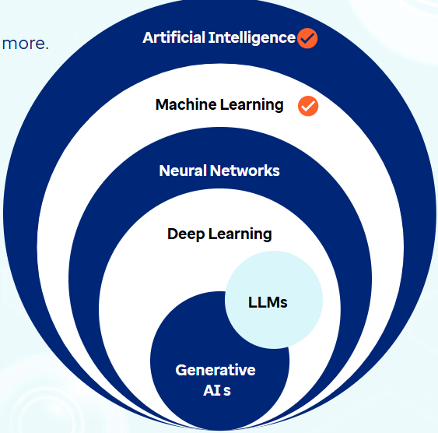

Artificial Intelligence

* A broad field in computer science, encompassing a variety of technologies that work together to enable machines to think, act, and learn in ways that mimic human intelligence.

Machine Learning

* It is a key subset of AI that focuses on training algorithms to learn from data and make decisions based on that knowledge. It allows machines to identify patterns and make predictions. ML itself can be divided into several types, including:

|  |  |
| --- | --- |
| Learning Type | Description |
| Supervised learning | * Training the model on labelled data |
| Unsupervised learning | * Working with unlabeled data to find hidden patterns |
| Semi-supervised learning | * Mix of both labelled and unlabeled data |
| Self-supervised learning | * Models sequentially generate their own labels from input data to learn patterns and features; * Large Language Models are based on this technique |
| Reinforcement learning | * Agent learning by interacting with an environment and receiving feedback; improves performance based on positive reinforcement and penalizes areas where negative feedback is received |

Neural Networks

* It is a subset of ML that is inspired by the structure of human brain.
* The networks consist of layers of interconnected 'neurons' or nodes, each processing inputs and passing results to the next layer.
* Neural networks are designed to model complex non-linear relationships within data by adjusting the weights of these connections as they process information.

Deep Learning

* It is an advanced subset of neural networks used to analyze and learn from vast amounts of unstructured data like images, videos etc.
* The 'deep' in deep learning refers to the multiple layers in a neural network. While a basic neural network might have three layers (input, hidden, and output), deep learning algorithms utilize many more hidden layers, allowing them to process and understand much more complex patterns in data.
* For example, deep learning excels in tasks involving unstructured data like images, text, or audio, by allowing **multi-dimensional input data** to efficiently recognize patterns across multiple layers in a way that traditional machine learning methods cannot.

|  |
| --- |
| **Multi-dimensional input data** refers to data that has more than one feature or attribute, often organized in a structured format like arrays, matrices, or tensors. In the context of **deep learning**, this is crucial because models need to process complex data types like:  Examples of Multi-Dimensional Input Data:  **1. Images**   * Represented as 3D arrays: **Height × Width × Channels** * Example: A 256×256 RGB image → shape: **(256, 256, 3)**   **2. Text**   * Represented as sequences of word embeddings or token vectors. * Example: A sentence of 10 words, each represented by a 300-dimensional vector → shape: **(10, 300)**   **3. Audio**   * Represented as 2D spectrograms or 1D waveforms over time. * Example: A 5-second audio clip sampled at 16kHz → shape: **(80,000, 1)**   **4. Video**   * Represented as 4D arrays: **Frames × Height × Width × Channels** * Example: A 10-second video at 30 fps, 128×128 resolution → shape: **(300, 128, 128, 3)** |

Generative Ai

* What it is: A type of AI that can **create new content—like text, images, music, or code**.
* How it works: It learns patterns from existing data and uses that to generate new, similar content.
* Examples:
  + Writing a poem or story
  + Creating artwork from a text prompt
  + Generating music or voice

Large Language Models (LLMs)

* What they are: A subset of GenAI focused specifically on language.
* What they do: Understand and **generate human-like text**.
* Examples:
  + Chatbots (like ChatGPT)
  + Auto-completing emails
  + Translating languages
  + Writing code

LLMs

|  |
| --- |
| **H**OW GEN AI AND LLMs ARE RELATED   * LLMs are a type of GenAI. * GenAI is the big umbrella, and LLMs are one of the most powerful tools under it—especially for anything involving language |

* Within deep learning, two significant subsets are
  + **Large Language Models (LLMs)** and
  + **Generative AI (GenAI).**
* LLMs, like GPT-3.5, GPT-4, and Google Gemini, are advanced AI models designed to understand, generate, and interact with human language.
* These models are called 'large' because they are trained on massive amounts of text data, containing billions or even trillions of parameters.
* These models excel at natural language processing tasks, including text generation, summarization, question answering, and code generation by leveraging deep neural network architectures like transformers and encoders.

## TYPES OF AI

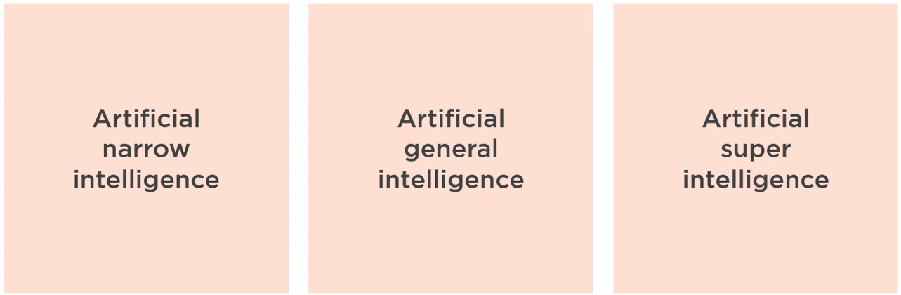

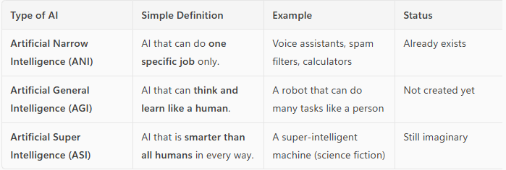

## COMPONENTS OF AI

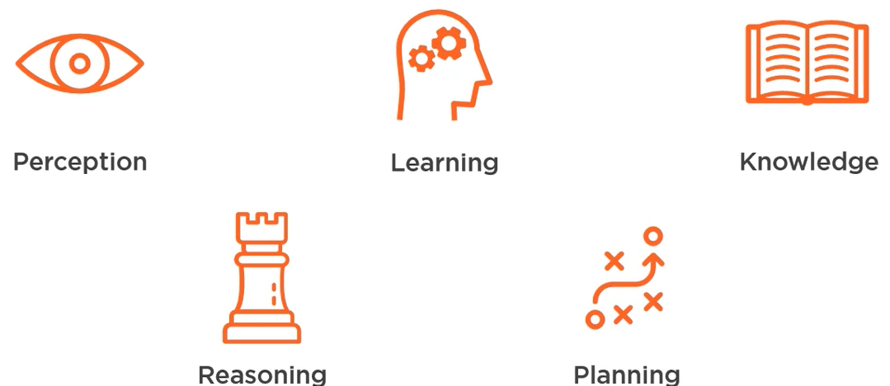

|  |  |  |
| --- | --- | --- |
| Perception   * AI’s ability to **sense the world** using data from cameras, microphones, sensors, etc. * *Example:* A self-driving car “seeing” a stop sign using a camera. | Learning   * AI’s ability to **learn from data or experience** to improve its performance over time. * *Example:* A music app learning your favorite songs and suggesting similar ones. | Knowledge   * The **information and facts** that AI stores and uses to make decisions. * *Example:* A medical AI system storing information about diseases and treatments. |
| Reasoning   * AI’s ability to **think logically** and solve problems using the knowledge it has. * *Example:* A chess AI figuring out the best move to win the game. | Planning   * AI’s ability to **set goals and decide steps** to reach them. * *Example:* A robot planning the best path to clean a room without missing spots. |  |

## HISTORY OF AI

Classical AI (Symbolic AI)

* Classical AI, also known as **symbolic AI**, emerged in the 1950s–1980s.
* It focused on using **explicit rules and logic** to represent knowledge and solve problems.
* It was based on the idea that intelligence could be achieved by manipulating symbols according to formal rules.

Key Features

* Rule-based systems
* Logic programming (e.g., Prolog)
* Expert systems (e.g., MYCIN, DENDRAL)

Setbacks and Failures

* **Brittleness:** Systems failed outside narrow domains.
* **Scalability issues:** Hard to encode all human knowledge as rules.
* **Lack of learning:** Could not adapt or learn from data.
* **Commonsense reasoning:** Struggled with ambiguity, context, and real-world variability.

Knowledge-Based AI

* A subfield of classical AI that focuses on **encoding expert knowledge** into a system using rules, facts, and ontologies to perform reasoning.

Examples

* Expert systems (e.g., MYCIN for medical diagnosis)
* Knowledge graphs
* Semantic web technologies

Strengths

* Transparent reasoning
* Useful in well-defined domains

Limitations

* Difficult to maintain and scale
* Inflexible in dynamic environments

Data-Driven AI (Statistical AI / Machine Learning)

* Data-driven AI refers to systems that **learn patterns and make decisions from data**, rather than relying on hand-coded rules.

Key Technologies

* Machine Learning (ML)
* Deep Learning (DL)
* Neural Networks

Advantages

* Can handle large, complex, and unstructured data
* Learns and improves over time
* Powers modern applications like image recognition, NLP, and recommendation systems

Challenges

* Requires large datasets
* Often lacks interpretability (black-box models)
* Bias and fairness concerns

AI Winter

AI Winter refers to **periods of reduced funding, interest, and progress** in AI research due to unmet expectations and repeated failures.

Major AI Winters

* **First AI Winter (mid-1970s):** Due to the failure of early machine translation and robotics.
* **Second AI Winter (late 1980s–early 1990s):** Caused by the collapse of expert systems and unmet commercial promises.

Consequences

* Funding cuts from governments and companies
* Decline in AI research and job opportunities
* Skepticism about AI’s potential

# WHAT IS MACHINE LEARNING

* Machine learning is a subfield of artificial intelligence.

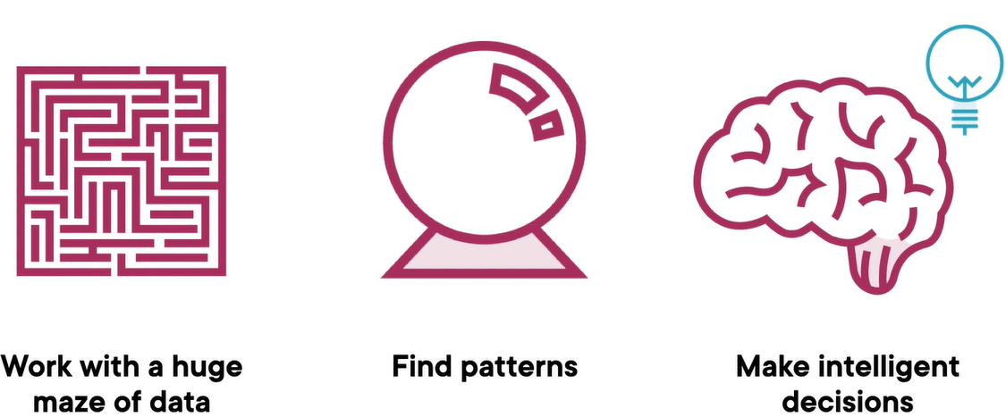

* It involves training computers on large amounts of data.
* Computers learn from data and make predictions or decisions.
* It allows computers to recognize patterns and improve their performance over time.
* Machine learning is used in various applications like image and speech recognition, recommendation systems, and predictive analytics.

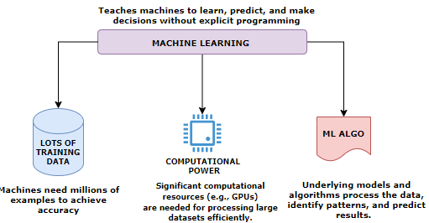

|  |
| --- |
| * We feed a set of data into a training algorithm 🡪 the algorithm produces a model 🡪then we feed new previously unseen data into that model and the 🡪model will predict what the data represent. |

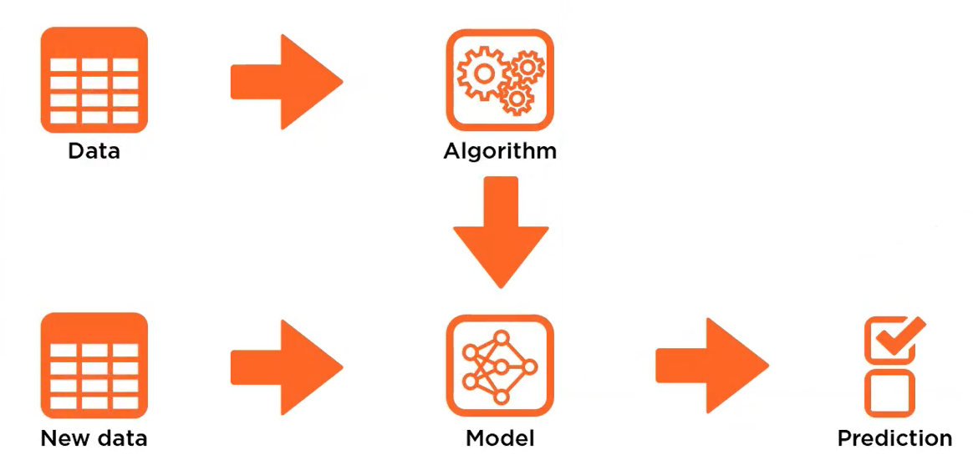

# MACHINE LEARNING TERMINOLOGIES

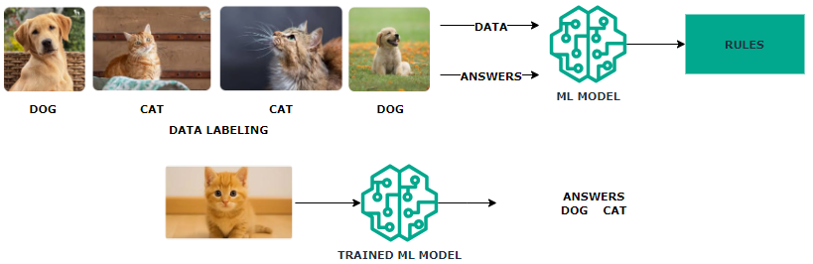

* **Machine Learning Model** learns by extracting patterns from the existing data, establishing rules automatically.
* In above example with multiple images of “dogs” & “cats” we train the model by labeling the training data. This common type of machine learning where the system is trained with labeled data (e.g., pictures of dogs and cats) is called **Supervised Learning**
* After Training the **Trained Model** can be used to classify new, unseen data.
* Machine learning systems adapt to new data without changing the program's code.

## DEEP LEARNING

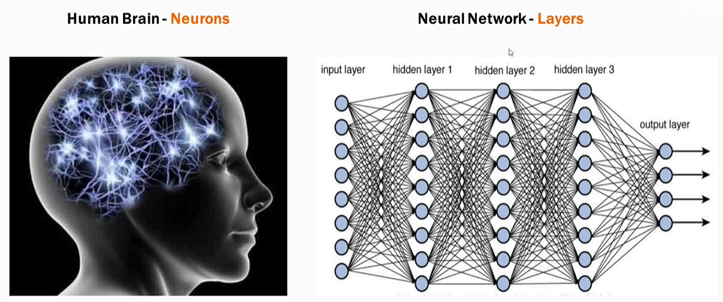

* Deep learning is a subset of Machine Learning based on neural networks which mimic the structure of human neurons.
* Neural networks consist of multiple computational layers.
* Each layer processes and enhances the data before passing it to the next layer.
* This multi-layer structure improves accuracy for complex tasks (e.g., text generation, image generation).
* *Neural network is the model that generative tools like ChatGPT are also using*.
* **Deep learning** enables models to handle complex inputs (like images or text) and produce complex outputs.
* It uses **neural networks**, which are inspired by the structure of the human brain.

How Neural Networks Work

* + **Input Layer**: Data enters through input neurons.
  + **Processing**: Each neuron performs mathematical operations.
  + **Forwarding**: Neurons pass results to connected neurons.
  + **Hidden Layers**: This process repeats across hidden layers.
  + **Output Layer**: The network generates a prediction.
  + A **deep neural network** has multiple hidden layers, allowing it to learn increasingly abstract features.

Example: Face Recognition

* + Input: Labeled face images.
  + Layer 1: Detects basic lines and edges.
  + Layer 2: Identifies facial features (eyes, nose, mouth).
  + Layer 3: Recognizes full face patterns.
  + Output: Predicts the person’s name.
  + Each layer extracts more complex features than the previous one.

Applications

* + Deep learning handles diverse data types: **text, images, audio, video**.
  + Used for tasks like **object detection**, **video segmentation**, and **real-time motion tracking**.
  + Can also generate **synthetic content**.

Limitations

* + **There is limitation of Deep learning when it comes to solving multi‑step problems. To solve these types of problems, we need reinforcement learning.**

EXAMPLE: IMAGE CLASSFICATION SYSTEM

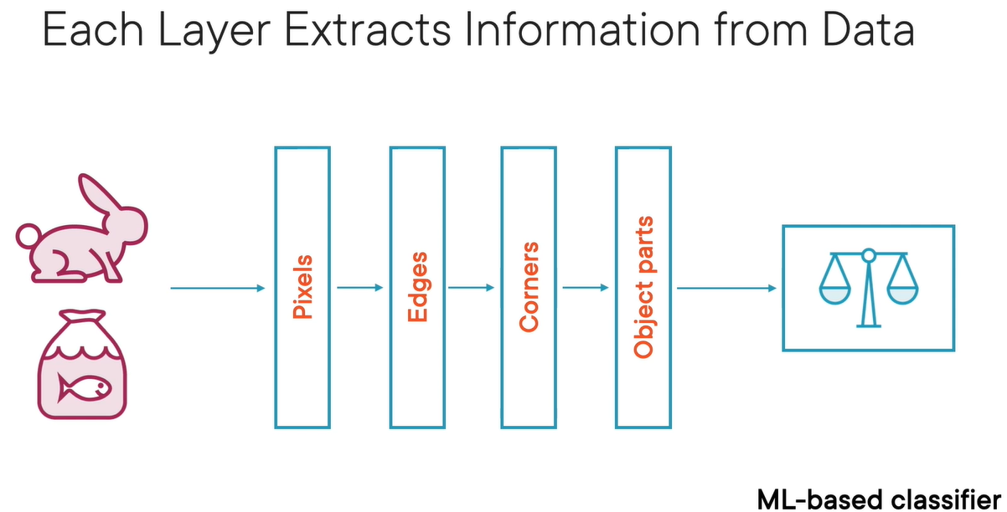

* Different layers of data extract different data from the corpus of data fed into it.
* In the above example of image classification system
  + The first layer extracts the pixels from the image
  + The second layer will put those pixels together to find edges
  + The second layer will put those edges together to find corners
  + The corners put together to view the object (image) and finally we get image recognition/classification

### ADVANTAGES OF DEEP LEARNING

* **Higher Accuracy**: Suitable for solving complex problems.
* **Generative AI Application**: Tools like ChatGPT use deep learning neural networks to enhance text generation accuracy.
* **Utilization of GPUs**: Recent advancements in computational power have made deep learning models more accessible and efficient.

## REINFORCEMENT LEARNING

Reinforcement Learning (RL): Solving Multi-Step Problems

* Reinforcement Learning is a type of machine learning where an agent learns by trial and error to achieve a goal in an environment.

The agent:

* + Observes the environment’s state (e.g., road conditions for a self-driving car)
  + Take actions that change the state (e.g., turning, accelerating)
  + Receives rewards or penalties based on the outcome of its actions
  + Over time, the agent learns which actions lead to better outcomes and refines its strategy.

## GENERATIVE AI

### NLP(NATURAL LANGUAGE PROCESSING)

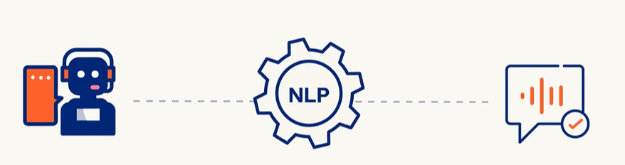

* Enabling and teaching computers to understand, interpret, generate, and respond to human language
* In **Generative AI (GenAI)**, **Natural Language Processing (NLP)** plays a **central role**. GenAI systems like ChatGPT, Bard, Claude, and others are built on advanced NLP techniques to understand and generate human-like language

How NLP Works

Data can be classified as

1. Structured (Sheets/Tables): This type of data is easy to standardize and categorize
2. Unstructured (Audio, Video, Social Media Posts, Email): Difficult standardize and categorize

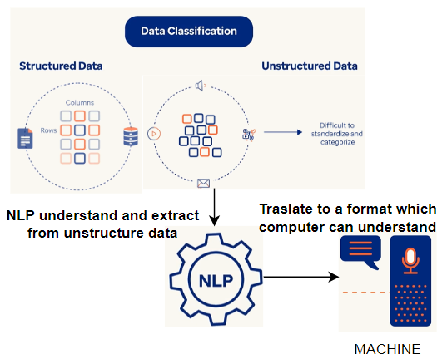

Key Areas of NLP

1. **Text Processing**: Tokenization, stemming, lemmatization, stop-word removal.
2. **Syntax & Parsing**: Understanding grammatical structure.
3. **Semantics**: Understanding meaning and context.
4. **Sentiment Analysis**: Detecting emotions or opinions in text.
5. **Machine Translation**: Translating text between languages.
6. **Speech Recognition**: Converting spoken language into text.
7. **Text Generation**: Creating human-like text (like what I do!).
8. **Named Entity Recognition** (NER): Identifying names, places, dates, etc.
9. **Question Answering & Chatbots**: Building systems that can answer questions or hold conversations.

Challenges in NLP

Syntactic Ambiguity

* **Definition**: When a sentence can be parsed in more than one way due to its structure.
* **Example**: *“I saw the man with the telescope.” 🡪*Did you use a telescope to see the man, or did the man have a telescope?

Lexical Ambiguity

* **Definition**: When a word has multiple meanings.
* **Example**: *“Bank” 🡪* Could mean a financial institution or the side of a river.

Misspellings or Typos

* **Definition**: Errors in spelling that can confuse NLP systems.
* **Example**: *“Recieve”* instead of *“Receive” 🡪*May lead to incorrect parsing or missed keyword matches.

Coreferential Ambiguity

* **Definition**: When it's unclear what a pronoun or noun phrase refers to.
* **Example**: *“John told Tom that he won.”🡪*Who won—John or Tom?

Uncertainty and Idiomatic Ambiguity

* **Definition**: Phrases that are not meant to be taken literally or are vague.
* **Example**: *“Kick the bucket” 🡪* Literally means to kick a bucket, but idiomatically means to die.

Mixing of Languages

* **Definition**: Use of multiple languages in the same sentence or conversation.
* **Example**: *“Mujhe pizza pasand hai, especially with extra cheese.” 🡪* Hindi-English mix (code-switching), common in multilingual societies.

Issues with Social Media Slang Abbreviations

* **Definition**: Informal or abbreviated language used online that may not be in standard dictionaries.
* **Example**: *“LOL”, “BRB”, “SMH” 🡪*These can confuse models not trained on such data.

Inadequate Training Data

* **Definition**: When the model hasn’t seen enough examples of a certain language, dialect, or context.
* **Example**: A chatbot trained only on formal English may struggle with regional slang or dialects.

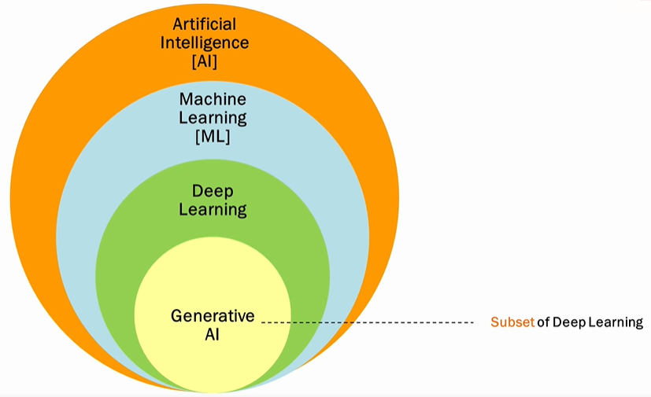

* **Gen AI is a subset of deep learning, and it uses artificial neural networks to process labeled and unlabeled data using supervised, unsupervised, and semi-supervised methods to generate new content like text, images, videos, or audio.**
* **Unlike conventional AI, Generative AI doesn't just classify or predict data; it generates brand-new content based on its training data.**

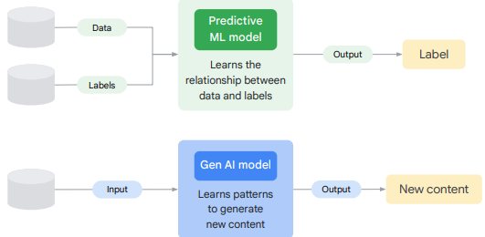

* In simple terms, traditional “predictive” machine learning models attempt to learn the relationship between the data and what we want to predict.
* A generative AI model attempts to learn patterns so that it can generate new content.

### CONVENTIONAL (PREDICTIVE) AI VERSUS GENERATIVE AI

**CONVENTIONAL AI**

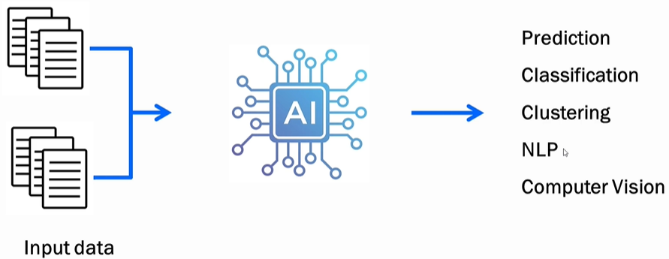

* Operates by learning from training data and making predictions, classifications, or performing language processing/computer vision.
* Example: Trained on apple images, it tells whether a supplied image is of an apple.

**GENERATIVE AI**

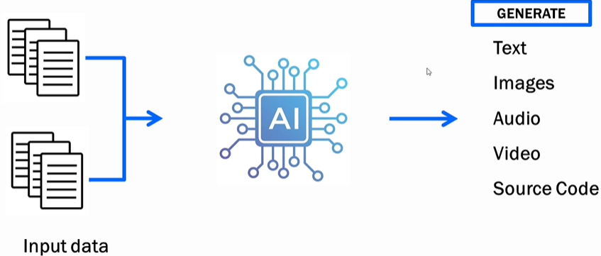

TYPES OF CONTENT GENERATED BY GEN-AI MODELS

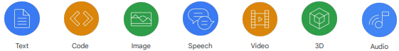

* Learning from training data and creating *new* content.
* Example: Trained on apple images, it generates a new apple image not extracted from the training data.

## MACHINE LEARNING MODEL

* This is an object that has been trained beforehand on a dataset. The model can then give output based on input values
* The machine learning object is nothing but a file or set of files. It would have the desired logic that would take in input and spur output data

## MACHINE LEARNING PROCESS

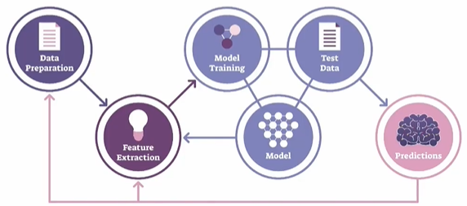

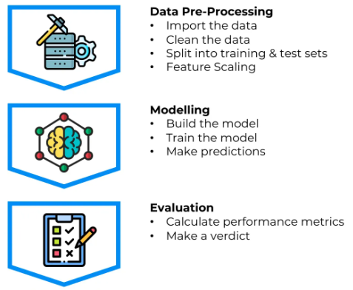

1. **DATA PREPARATION**:
   1. This step involves gathering and cleaning the data to make it suitable for analysis.
   2. It includes tasks like handling missing values, removing outliers, normalizing or standardizing the data, and splitting the data into training and testing sets.
2. **FEATURE EXTRACTION**:
   1. Feature extraction is the process of selecting or creating relevant features from the data that will be used as input for the machine learning model.
   2. It involves identifying the most informative attributes or transforming the data into a more meaningful representation that captures the underlying patterns and relationships.
3. **MODEL TRAINING**:
   1. Model training is the process of using the prepared dataset to teach the machine learning model to recognize patterns and make predictions.
   2. During this step, the model learns from the input data and adjusts its internal parameters to optimize its performance.
4. **MODEL**:
   1. The model is the representation of the learned patterns and relationships from the training data.
   2. It encapsulates the knowledge gained during the training process and can be used to make predictions or decisions on new, unseen data.
5. **TEST DATA**:
   1. Test data is a separate set of data that is not used during the model training. It is used to evaluate the performance of the trained model and measure its accuracy.
   2. The test data should be representative of the real-world scenarios the model will encounter.
6. **PREDICTION**:
   1. Once the model is trained and evaluated, it can be used to make predictions on new, unseen data.
   2. The model takes the input data, processes it using the learned patterns, and generates predictions or decisions based on the trained knowledge.
   3. The accuracy and reliability of the predictions depend on the quality of the model and the suitability of the input data.

## MACHINE LEARNING MODEL AND DATASET

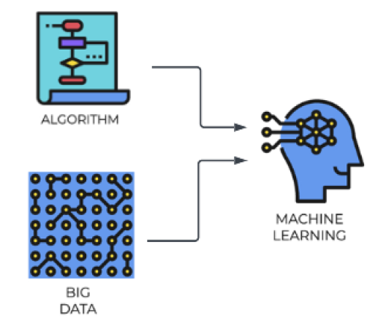

### DATA SET

* A dataset is a collection of structured or unstructured data that is used for analysis, machine learning, or other data-related tasks. It typically consists of multiple data points or instances, where each data point represents an observation or sample.
* A dataset can include various types of data such as numerical, categorical, text, images, or time series.
* Datasets are crucial for training and evaluating machine learning models. They provide the necessary information for the model to learn patterns and relationships.
* Datasets can be sourced from various places, including public repositories, research institutions, or generated internally within an organization
* Common operations on datasets include cleaning, transforming, splitting into training and testing sets, and feature engineering.

### TRAINING SET AND TEST SET

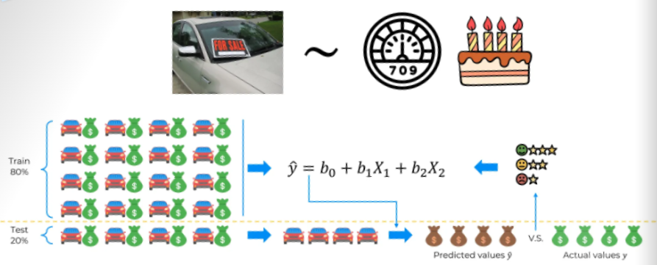

Importance Of Splitting Data Set into a training set and a test set.

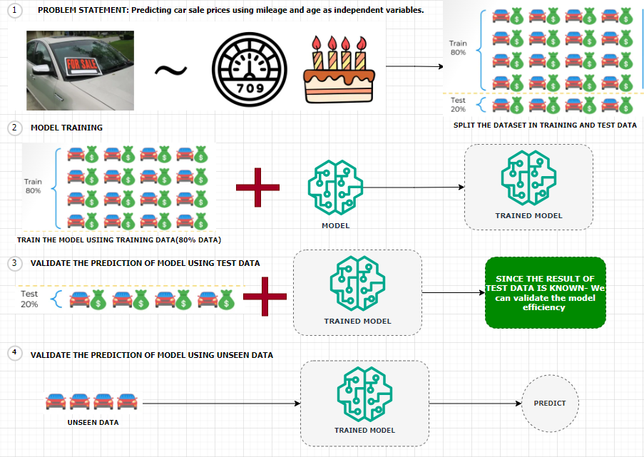

Predicting Car Sale Prices Using Linear Regression

Let’s consider a scenario where we aim to **predict the sale prices of cars** using a **linear regression model**. In this case:

* **Dependent Variable**: Sale price of the car
* **Independent Variables**:
  + Mileage of the car
  + Age of the car

**Dataset Overview**

We are provided with a dataset containing information on **20 cars**. To build and evaluate our model effectively, we split the dataset into two parts:

* **Training Set (80%)**:
  + Contains data for **16 cars**
  + Used to train the linear regression model
* **Test Set (20%)**:
  + Contains data for **4 cars**
  + Set aside before training to evaluate the model’s performance

Model Training and Evaluation

1. **Model Building**:  
   We train the linear regression model using only the training set. This means the model learns the relationship between mileage, age, and sale price from these 16 cars.
2. **Prediction on Test Set**:  
   After training, we apply the model to the 4 cars in the test set. These cars were **not part of the training process**, so the model has **no prior knowledge** of them.
3. **Comparison with Actual Prices**:  
   Since we already know the **actual sale prices** of the test set cars, we can now compare:
   * **Predicted Prices** (from the model)
   * **Actual Prices** (from the dataset)
4. **Model Evaluation**:  
   This comparison allows us to assess how well our model performs on unseen data. Metrics such as **Mean Absolute Error (MAE)** or **Root Mean Squared Error (RMSE)** can be used to quantify the model’s accuracy.

#### EXAMPLE

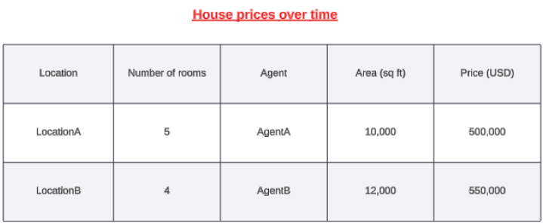

* Let's say we are building a ML model that can predict the house prices over time. For that we need to have prior information in place about the houses that were already sold over the previous years.
* The information can be the location of the house, the number of rooms, the agent involved in selling the house,

the area in square feet, and what was the price in USD. (as shown in above table)

* To train the model using historical data, we need to select the relevant features/column. ( for example, Agent column is irrelevant for price prediction)
* **This is the historical data is then used to training the ML model. Hence the data like - location, the number of rooms, and the area will become the features. Features are the measurable property within the dataset and the price is going be the label.**

### FEATURES AND LABELS

#### FEATURES

* Features, also known as input variables or independent variables, are the measurable properties or characteristics of the data that are used to make predictions or classifications.
* They represent the input data that the model will analyze and learn patterns from. For example, in the context of predicting house prices, features could include the location, number of rooms, and area of a house.
* Each feature is represented by a specific value or attribute.

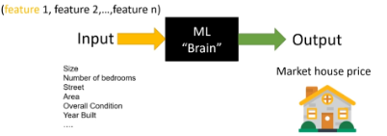

* Selecting the right features is a critical step to ensure the accuracy of ML models, something that is called feature selection.

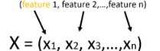

***Mathematically the list of input features will be represented as a vector with the size of N like x1,x2, x3 until Xn***

#### LABELS

* Labels, also known as target variables or dependent variables, are the values that the model aims to predict or classify.
* Labels represent the desired output or outcome based on the input data. In the house price prediction example, the label would be the actual price of the house.
* The model analyzes the provided features and attempts to learn patterns that will help predict or estimate the label.

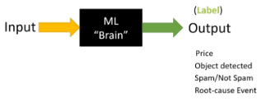

#### FEATURE AND LABELS

|  |
| --- |
| * During the training process, the model is presented with a dataset that contains both the features and the corresponding labels.      * The model learns the relationship between the features and labels by adjusting its internal parameters to minimize the difference between its predicted output and the actual labels. * Once trained, the model can then be used to make predictions or classifications on new, unseen data by analyzing the features and producing a predicted label. * In summary, features are the measurable properties of the data that serve as input for the model, while labels are the desired output or outcome that the model aims to predict or classify. The relationship between the features and labels is learned by the model during the training process. |

**IN A NUTSHELL, the summary is**

|  |
| --- |
| * Building a model to predict house prices over time * Prior information about sold houses including location, number of rooms, agent, area, and price in USD * Training the model using historical data, selecting relevant features and the price as the label * Cleaning the data, removing missing values, and performing feature engineering * Splitting the dataset into training and testing sets, using the training set to train the model and the testing set to evaluate its accuracy * Testing the accuracy and precision of the model by comparing its predictions with the actual values * Deploying the model and allowing users to make predictions based on new input data, such as location, number of rooms, and area. |

# GENERATIVE AI – IN DETAILS

WHAT IS GENERATIVE AI

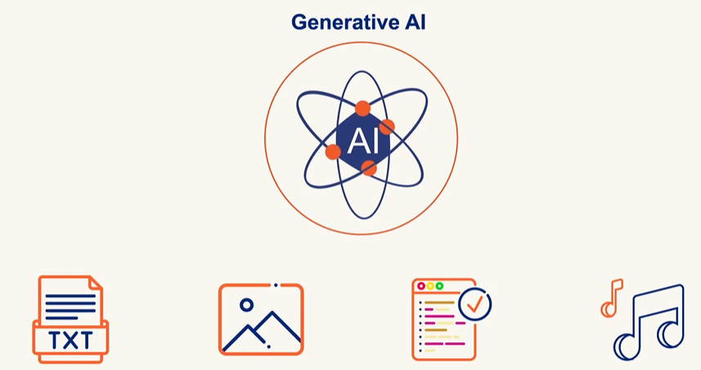

Generative AI creates new content like Text , Image , Audio and Code based in learned Pattern unlike Traditional AI which classifies and predict

* Artificial Neural Network (ANN) is the foundation of Generative AI. It’s a type of machine learning model inspired by the structure and functioning of the human brain

GENERATIVE AI CHALLENGES

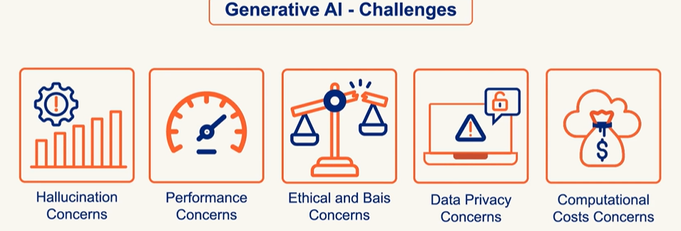

## GENERATIVE AI VS DISCRIMINATIVE AI

* **Generative AI models** learn the **joint probability** of inputs and outputs (P(x, y)). This means they understand how data is structured and can **generate new data** that looks similar to what they’ve seen.

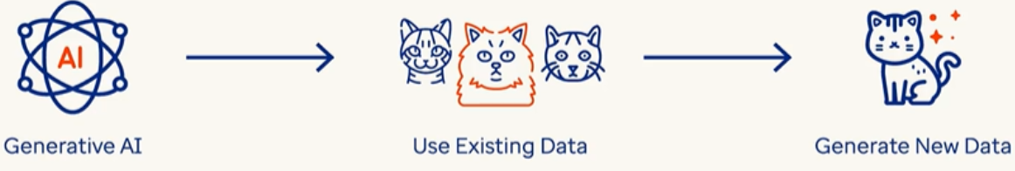

* **Discriminative AI models** learn the **conditional probability** (P(y|x))—they focus on **distinguishing** between different categories or classes. Its goal is to **classify** or **predict** based on input data.
* Example:
  + **Spam filters** classify emails as spam or not spam.
  + **Face recognition systems** identify people from images.
  + **Sentiment analysis** detects if a review is positive or negative.

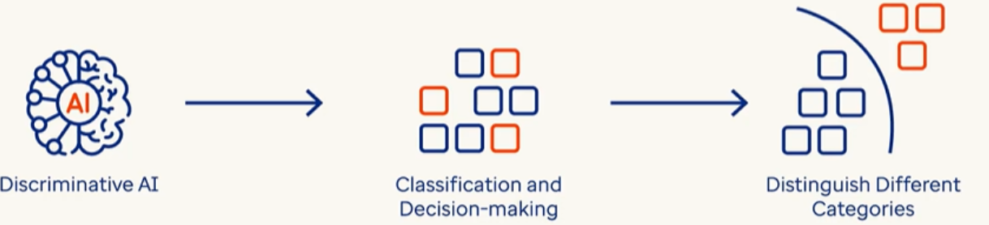

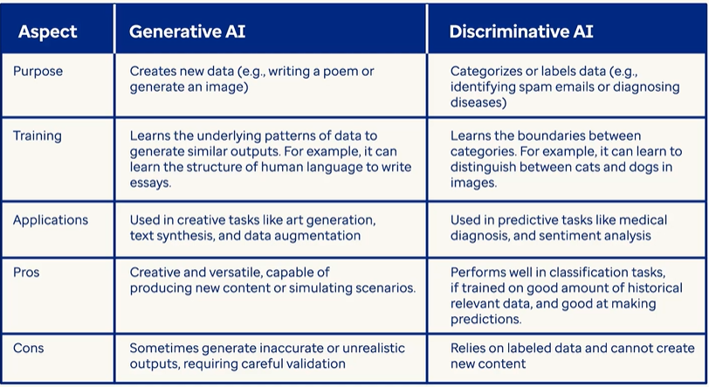

Artificial Neural Networks (ANNs)

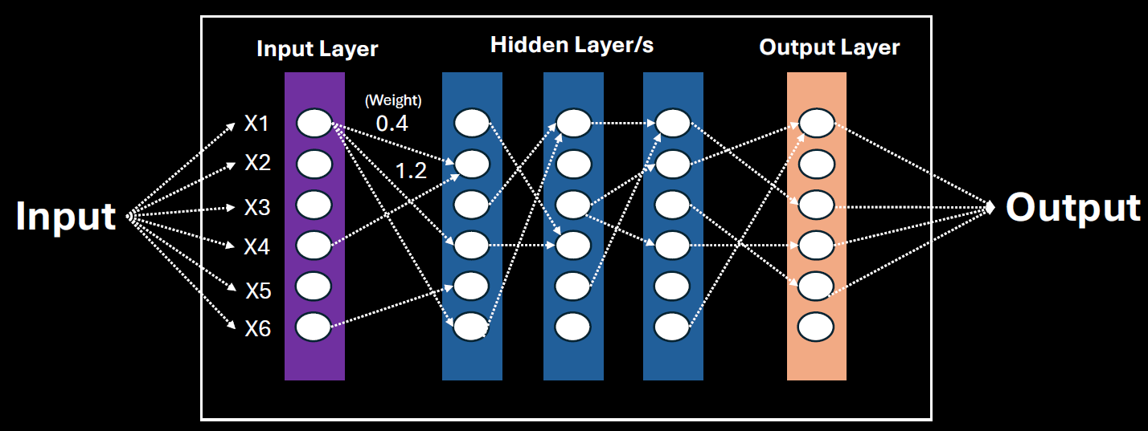

An ANN is made up of layers of **nodes (neurons)**:

1. **Input Layer** – Takes in the raw data/features (e.g., pixels of an image, words in a sentence).
2. **Hidden Layers** – Perform computations and extract features. There can be one or many of these.
3. **Output Layer** – Produces the final result (e.g., classification, prediction, generated content).

Input Layer – Where It All Begins

* This is the **first layer** of the network.
* It receives **raw data** like numbers, images, or text.
* The data is broken into **features** (e.g., for predicting apartment price: size, number of rooms, location).
* Each feature becomes an **input node** in the network.

Hidden Layers – The Brain of the Network

* These are the **intermediate layers** between input and output.
* They **process the input data** and extract deeper patterns or sub-features.
* More hidden layers = more ability to learn **complex relationships** in the data.

Output Layer – The Final Decision

* This layer gives the **final result** of the network.
* Depending on the task, it could:
  + Classify (e.g., spam or not spam),
  + Predict (e.g., apartment price),
  + Generate (e.g., new text or images).

Connections and Weights – How Learning Happens

* Every node is connected to others in the next layer.
* Each connection has a **weight**—a number that shows how important that connection is.
* During training, the network **adjusts these weights** to improve accuracy.
* For example, if “apartment size” is very important, its connection will have a **higher weight**.

Training the Network – Learning from Data

* The network learns by comparing its output to the correct answer and adjusting weights.This process is called **backpropagation**.
* Over time, the network learns which features are most important and how to combine them.

## LARGE LANGUAGE MODELS(LLMs)

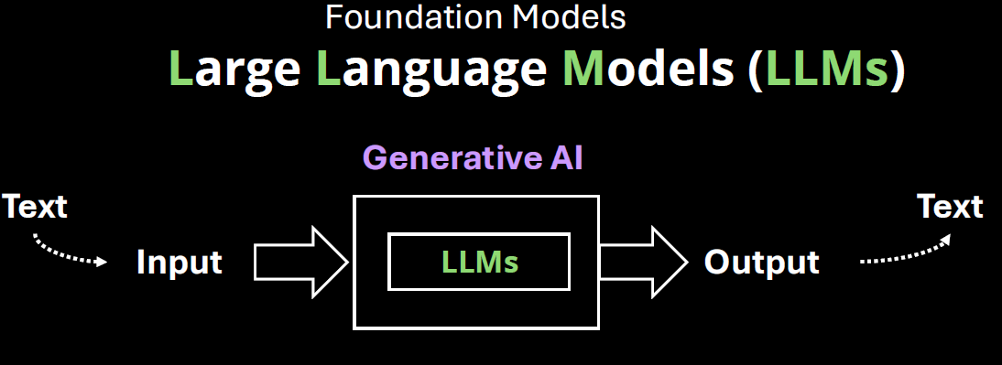

* LLMs are AI models designed to understand and generate human-like text.
* Unlike general generative AI (which handles text, images, audio, video, etc.), **LLMs deal exclusively with text—words, grammar, sentences, and contextual understanding.** Example: **ChatGPT**, **GPT-4**, **Claude**, **Gemini**, and **LLaMA**

## BENEFITS OF LLMS

### HOW LLMS WORK

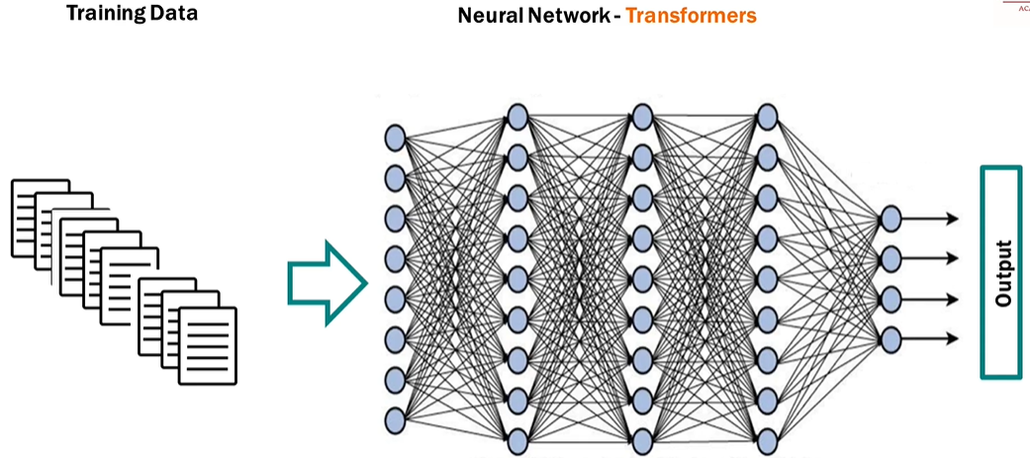

1. Training Phase

* The LLM is trained using **self-supervised learning**: it learns by predicting **missing words** in a sentence.
* For example: "The cat sat on the ___." → Model tries to guess "mat".
* It sees **billions or trillions of words** from diverse sources, learning grammar, facts, reasoning patterns, and even some coding skills.

2. Tokenization

* Text is broken down into **tokens** (which may be words, subwords, or characters).
* For example, “ChatGPT is smart” → ["Chat", "G", "PT", "is", "smart"].

3. Transformer Architecture

* A special deep learning model that uses **attention mechanisms** to understand the context of each word in relation to others in the sentence.
* For example, it knows the word “bank” can mean money or river, depending on context.

4. Inference (When You Use It)

* When you type a prompt, the LLM:
  + Converts your input into tokens.
  + Uses its trained model to predict the **next best token**.
  + Repeats until it completes a meaningful output.
* This happens very fast — like autocomplete on steroids.

What Can LLMs Do?

* Answering questions
* Write essays, emails, or stories
* Translate languages
* Generate code
* Summarize documents
* Act as chatbots
* Reason through logic puzzles (to some extent)

Examples of LLMs

|  |  |  |
| --- | --- | --- |
| **Model** | **Organization** | **Key Use** |
| GPT-4 | OpenAI | General purpose, ChatGPT |
| Claude | Anthropic | Helpful assistant, safety-focused |
| Gemini | Google | Multimodal AI |
| LLaMA | Meta | Open-source, research-focused |

Why it feels like LLMs are answering questions

* It feels like an LLM is answering questions because it has learned to predict the next token in a way that mimics intelligent responses — by learning patterns from millions of real questions and answers.

|  |  |  |
| --- | --- | --- |
| When we ask:  > "What is the capital of France?" | The model sees a familiar pattern. It has seen many examples like this during training:  Q: What is the capital of France?  A: Paris  Q: What is the capital of Germany?  A: Berlin | So, it has learned that when someone types:  > "What is the capital of ___?"  The best next tokens are usually:  > " [Country name]" → "?" → " A: [Capital]"  So it predicts:  " Paris"   * That’s it. It doesn’t "know" what Paris is — it just has seen that people answer that question with “Paris” so many times that it becomes the most likely token sequence. |
| **Chain of Tokens Feels Like Thought**  Let’s say we ask:  > "Can you explain black holes?" | It starts predicting:  "Sure! A black hole is a region in space..."  Then it keeps going with:  "...where gravity is so strong that not even light can escape..."   * Each time, it's predicting the next most likely token, based on what it has already said and what it's seen in similar explanations before. | * This sequence of predictions sounds natural, structured, and smart — because it's imitating how humans write or speak. * It's Like a Super Autocomplete |

Analogy: The Super Parrot with a Giant Memory

Imagine a **super parrot** named **GPTy** who has:

1. **Read every book**, website, chat, and textbook ever written.
2. **Doesn’t understand the world**, but **remembers how humans talk** — sentence by sentence.

Now, we ask the parrot: “What is the capital of Japan?"

* GPTy searches its memory and remembers **100,000+ times** someone asked that same question, and people always replied: "Tokyo."
* So it just **repeats the most likely answer** it has seen:→ **"Tokyo"**

|  |  |
| --- | --- |
| **Simple Simulation (in Code)**  Let’s simulate a tiny LLM that only learned how to respond to one question:  def tiny_model(prompt):  if prompt == "What is 2 + 2?":  return "4"  elif prompt.startswith("What is"):  return "I'm not sure, but maybe check a calculator!"  else:  return "Can you ask that again?" | print(tiny_model("What is 2 + 2?")) # → 4  print(tiny_model("What is 10 x 10?")) # → "I'm not sure..."  print(tiny_model("Tell me a joke.")) # → "Can you ask that again?"  That’s basically what a real LLM does — except:   * It doesn't have **if-else** rules. * It has **math-based probabilities** to guess the next best word/token. * It was trained on **terabytes** of data, not 3 lines like our tiny version. |

#### PROMPTS & TOKENS

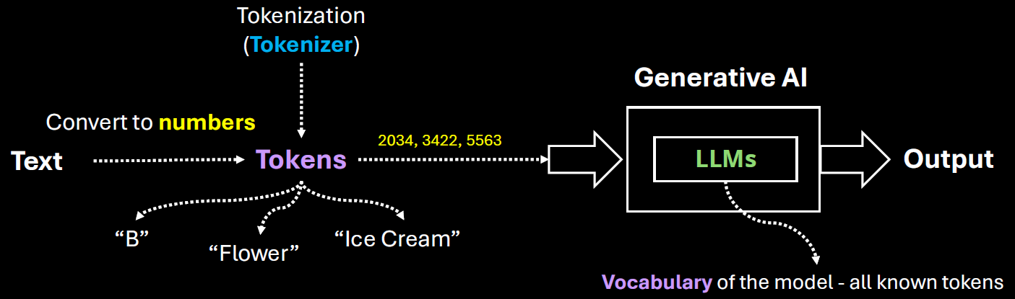

**WHAT IS A PROMPT?**

* A **prompt** is the **input** we give to a language model — it's the question, instruction, or text we type to get a response. We Think of it like a **conversation starter** or a **command**.It can be a single word, a sentence, or a long paragraph.

**WHAT IS A TOKEN?**

* A **token** is a **chunk of text** — usually a word or part of a word — that the model processes. It is numerical representation (converted by Tokenizer)of word or parts of word , phrases or a character
* Tokens can be as short as one character or as long as one word.
* For example:
  + "ChatGPT" → 1 token
  + "unbelievable" → might be split into ["un", "believ", "able"] → 3 tokens
  + "I am happy." → 4 tokens (["I", " am", " happy", "."])
* Most models (like GPT-4) use a tokenizer to split text into tokens. The number of tokens affects:
  + **Cost** (for API usage)
  + **Speed**
  + **Context limit** (e.g., GPT-4-turbo can handle up to 128k tokens)

|  |
| --- |
| * The set of all tokens used by the model is called the vocabulary of the model * The process of splitting text into tokens is called tokenization. |

**TOKENS IN CHAT GPT**

|  |  |
| --- | --- |
|  | Open the URL: <https://platform.openai.com/tokenizer>  Enter the desired prompt  It will show how many has been created for a given prompt along with attention score (based on color code)  Note : Each model tokenize the prompt differently as they use different tokenizers |

##### TOTAL TOKENS

* Tokens are numerical representation of characters, words or phrases

|  |
| --- |
| * Tokens are a fundamental metric for measuring usage in an AI system. * **Total tokens = Input tokens (**The number of tokens in the prompt or message you send**) + Output tokens(**The number of tokens in the model's response**)**   . **WHY IT MATTERS?**   * Language models have a **token limit** per interaction (e.g., 8,000 or 32,000 tokens depending on the model). * If the total number of tokens exceeds the limit, the model may truncate the input or fail to generate a complete response. |

##### CONTEXT WINDOW

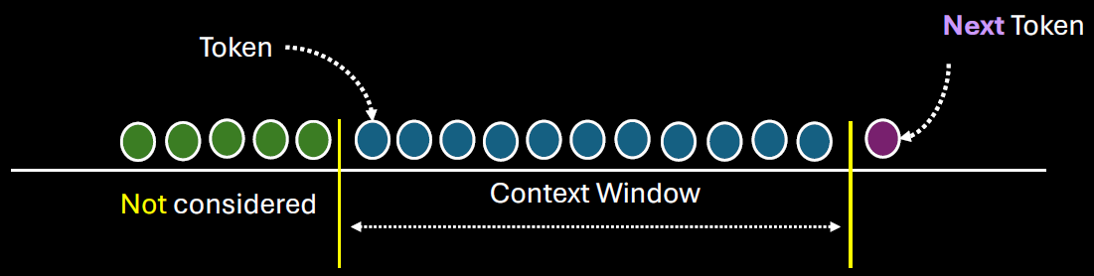

* The context window refers to the maximum number of tokens (input + output) that the model can "see" or process at one time.
* The context window includes:
  + **Your input (prompt, messages, instructions)**
  + **The model’s output (response)**
  + **Any previous conversation history (if it's part of the current session)**
* Different models have different context window sizes. For example:
  + GPT-3.5: ~4,096 tokens
  + GPT-4 (standard): ~8,192 tokens
  + GPT-4 Turbo: up to 128,000 tokens

**WHY DO IT MATTERS?**

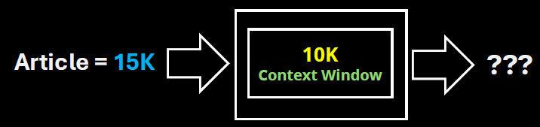

* If the conversation exceeds the context window, older parts of the conversation may be truncated or forgotten.
* This affects the model’s ability to maintain long-term coherence or remember earlier details.
* For example, a LLM with context window of 10K, which is fed by an article of 15K token – it will truncate the token after 10K tokens of the Article. Hence the long documents may need to be chunked to fit within the context window of the LLM

### MODEL TYPES (LLM TYPES)

#### GENERAL PURPOSE AND DOMAIN-SPECIFIC LLMS

The distinction between General Purpose LLMs and Domain-Specific LLMs lies in their training data, capabilities, and intended use cases.:

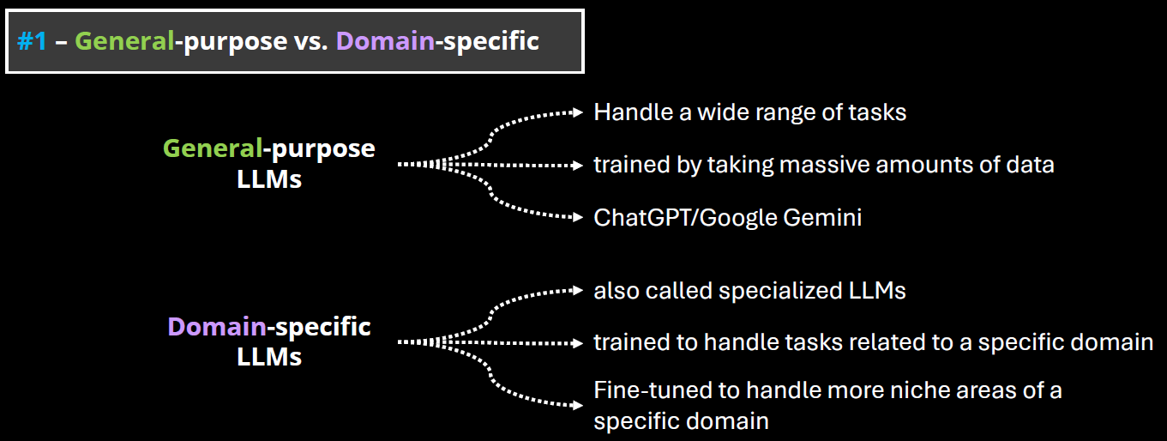

##### GENERAL PURPOSE LLMS

* These are large language models trained on a broad and diverse dataset that spans many domains (e.g., science, literature, law, medicine, pop culture, etc.).
* Examples: GPT-4, Claude, Google Gemini, LLaMA.
* Strengths:
  + Versatility: Can handle a wide range of tasks (e.g., summarization, translation, coding, creative writing).
  + Adaptability: Can generalize well across different topics and user needs.
  + Scalability: Useful in applications where domain-specific knowledge is not required.
* Limitations: May lack deep expertise in specialized fields.

##### DOMAIN-SPECIFIC LLMS

* These are LLMs trained or fine-tuned on specialized datasets from a particular field (e.g., legal, medical, financial, scientific).
* Examples: Med-PaLM (medical), FinGPT (finance), BioGPT (biomedical), Legal-BERT (legal texts)
* Strengths:
  + High accuracy in domain-specific tasks.
  + Better understanding of terminology, context, and nuances in the field.
  + Often used in regulated industries where precision is critical.
* Limitations:
  + Limited generalization outside their domain.
  + May require frequent updates to stay current with domain knowledge.
  + Less flexible for multi-domain tasks.

##### OPEN AND CLOSED SOURCE LLMs

**The distinction between Open-Source and Closed-Source LLMs revolves around accessibility, transparency, control, and community involvement.**

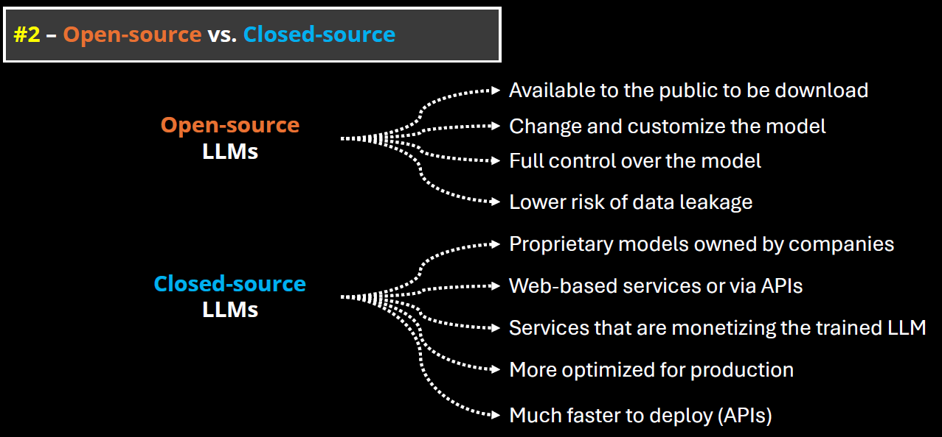

###### OPEN-SOURCE LLMS

* These models have their code, weights, and training data (or methodology) publicly available. Anyone can inspect, modify, or fine-tune them.
* Examples: Meta’s LLaMA (e.g., LLaMA 2, LLaMA 3), Mistral, Falcon,OpenChat, BLOOM (by BigScience)

CLOSED-SOURCE LLMS

* These models are proprietary. The model weights, training data, and architecture details are not publicly available.
* Examples: OpenAI’s GPT-4, Anthropic’s Claude, Google’s Gemini, , Cohere Command R+,Amazon Titan

### EMBEDDINGS IN GENERATIVE AI

* Embeddings are numerical representations of text—a way to convert words into numbers so machines can understand and process them.
* Machines do not inherently understand text; they operate using numbers. Embeddings allow machine learning models to interpret meaning, context, and relationships between words.

**KEY FUNCTIONALITY OF EMBEDDINGS**

1. **CAPTURING MEANING**: Embeddings reflect the semantic meaning of words or sentences.
2. **CONTEXT UNDERSTANDING**: Embeddings account for the context of text (e.g., same word in different sentences/sentiments - “great” in sarcasm vs happiness).

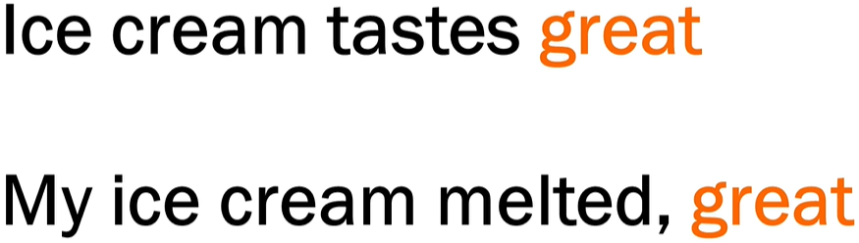

1. **RELATIONSHIPS**:

* Words with strong associations (e.g., "ice" and "cream") have similar embeddings, reflecting their connection.
* Models understand the proximity and sequence of words based on embeddings.

**HOW EMBEDDINGS ARE GENERATED**

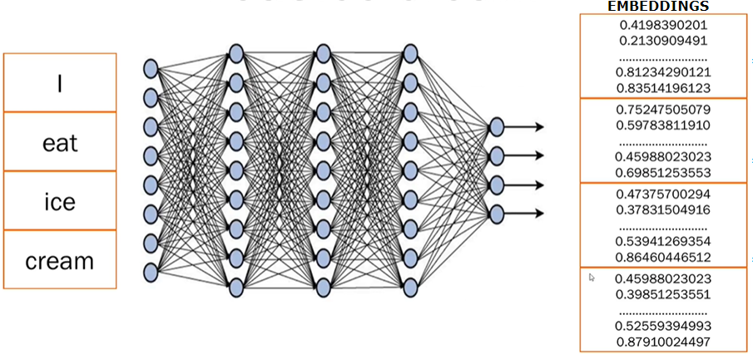

1. **STEP 1:** **BREAKING TEXT INTO TOKENS**

* Sentences are broken into smaller pieces or tokens (e.g., splitting "I eat ice cream" into 4 tokens—"I", "eat", "ice", "cream").

2. **STEP 2: NEURAL NETWORK PROCESSING**:

* Trained **transformer models** analyze the text, generate embeddings, and capture meaning, context, and relations between tokens.

1. **STEP 3: NUMERICAL EMBEDDINGS:**

* Each token is converted into numerical data (random numbers).
* These numbers represent embeddings, storing all learned information about the word or sentence.
* Only the transformer model understands what these embeddings mean based on its training.

### FINE TUNING

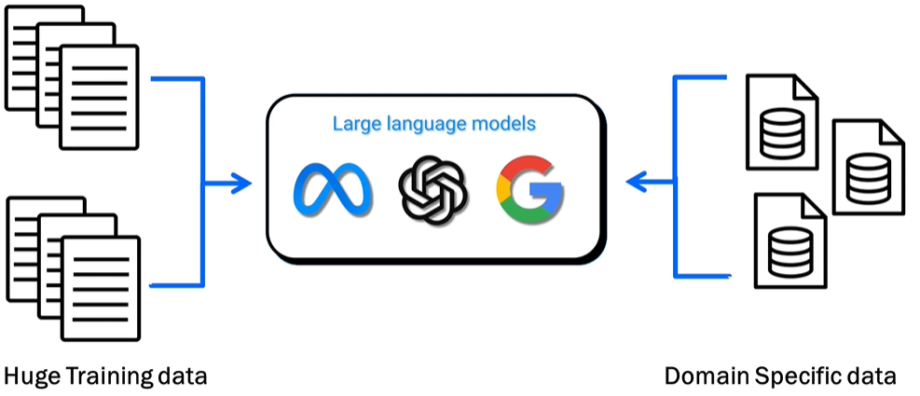

WHAT IS FINE TUNING

* Adjusting a pre-trained large language model (LLM) to provide better results on specific tasks or domain-specific datasets (e.g., healthcare, finance, etc.).

WHAT IS THE PURPOSE OF FINE TUNING

* Enhance the model's ability to generate focused and precise results on specialized datasets.
* Example: Fine-tuning an LLM on medical data improves its accuracy in answering medical queries compared to a general-purpose/pre-trained model.

#### DIFFERENT WAYS TO FINE TUNNING A MODEL

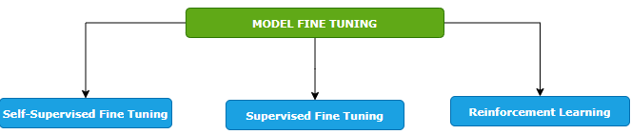

##### SELF-SUPERVISED FINE TUNING

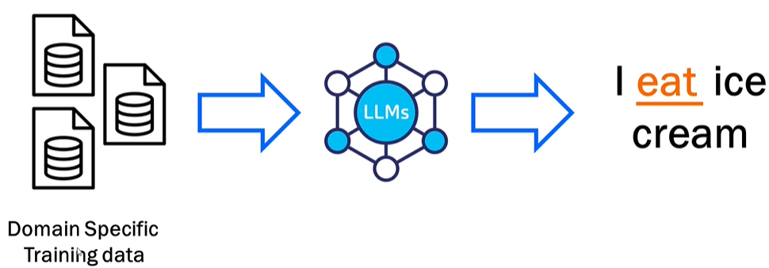

* Training the model on a domain-specific dataset. Means – we give the foundation model a big pile of training data that is specific to our domain, and the model will learn from it. In this way, the model learns to predict missing pieces of data.
* Example - when we say I ice cream, the model predicts that the missing word is eat.
* This is like how the foundation model is trained but the key difference here is that we are fine tuning the model by providing the domain specific data set. Example - Like if we want to train it on health care data set, we will pass it - the drug structure, scientific studies, all the documents that are related to drug and the model will learn from it and it would be able to generate content based on that.

##### SUPERVISED FINE TUNING

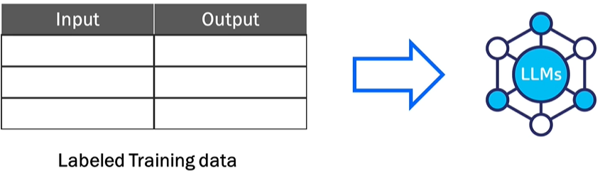

* The model is trained using a labeled dataset where both inputs and outputs are provided.
* Example: Input: "How do I find a broken bone?" → Output: "X-ray."
* Helps the model learn more precise responses based on labeled data.

##### REINFORCEMENT LEARNING

|  |  |
| --- | --- |
|  |  |
| **LOW SCORE FOR BAD RESULT** | **HIGH SCORE FOR GOOD RESULTS** |

* **Feedback-based learning**.
* The model generates outputs, and scores are assigned based on quality (high score for good results, low score for bad results).
* The model learns overtime from the feedback to improve predictions.

##### KEY FEATURES OF FINE TUNING

1. **STARTS FROM A PRE-TRAINED MODEL**: Fine tuning builds on top of a foundation model already trained on large datasets—it does not start from scratch.
2. **REQUIRES DOMAIN-SPECIFIC DATA**: We must provide good-quality, specific data for training tailored to your use case (e.g., drug data for healthcare).
3. **No Universal SOLUTION**: Each task/use case is unique, requiring case-specific implementation and variations.
4. **ITERATIVE PROCESS**: Fine tuning is repetitive and requires multiple cycles of iteration and adjustments for optimal results.

## DEEP LEARNING ARCHITECTURE

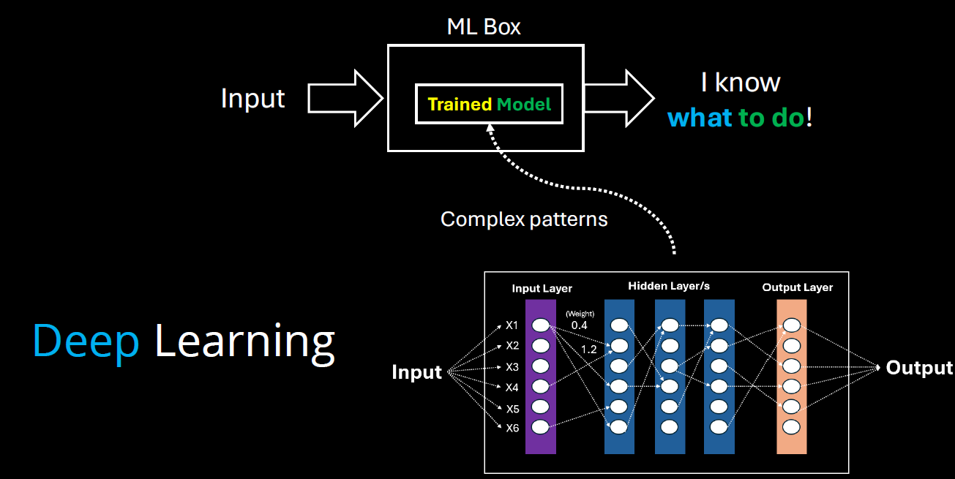

* **Model Training**: In machine learning, training a model means teaching it to recognize patterns in data.
* **Model = Knowledge**: The trained model represents the system’s learned knowledge from the data.
* **Complex Patterns**: When data patterns are too complex for traditional methods, **deep learning** is used.
* **Deep Learning**: Uses **multiple layers** in a neural network to detect and learn complex patterns.
* **Layered Learning**: Each layer in the network captures increasingly abstract features from the data.
* **Evolution of ML**: Deep learning is a more advanced stage in the evolution of model training, enabling machines to handle tasks like image recognition, language understanding, and more.

## DIFFERENT ARCHITECTURE OF DEEP LEARNING

### RECURRENT NEURAL NETWORKS (RNNS)

* RNNs are a type of neural network designed to handle **sequential data** (like text, time series, or speech).
* They are good at remembering **previous inputs** using a concept called **"memory"**, which helps them understand context.

**HOW DO THEY WORK?**

* They process one element at a time in a sequence.
* Each step’s output depends on:
  1. The current input.
  2. The previous step’s output (memory).
* This loop-like structure gives RNNs their “recurrent” nature.

**WHERE ARE RNN USED?**

1. Text generation (e.g., writing like a human).
2. Language translation (e.g., English to Hindi).
3. Speech recognition (e.g., Siri or Google Assistant).
4. Stock price prediction (based on past trends).

### CONVOLUTIONAL NEURAL NETWORKS (CNNS)

* Designed for image and video processing.
* Used in tasks like image classification, object detection, and segmentation.
* Not ideal for language tasks, but powerful in visual domains.

### TRANSFORMER ARCHITECTURE

* **Transformer Architecture is now the standard for generative AI.**
* Processes data in parallel, not sequentially like RNNs → much faster and scalable.
* Uses GPUs (Graphics Processing Units) for efficient training and inference.
* Cloud platforms (AWS, Google Cloud) use GPUs to train large models.
* It makes use of something **Attention Mechanism**

#### ATTENTION MECHANISM

* Like the way we use **colored markers** to highlight important words in a sentence, transformer architecture **focus on key parts** of the input.
* In this architecture – it breaks down the word in multiple tokens called **tokenization**
* Then it calculates the attention **score** of each pair of words to understand relationships between words (e.g., “calculate” is linked to “sum”) – as shown below!
* Hence - using the transformer architecture, the parallel processing coupled with the attention mechanism enables Gen-AI system to digest more data, process it faster, and catch more complex patterns.

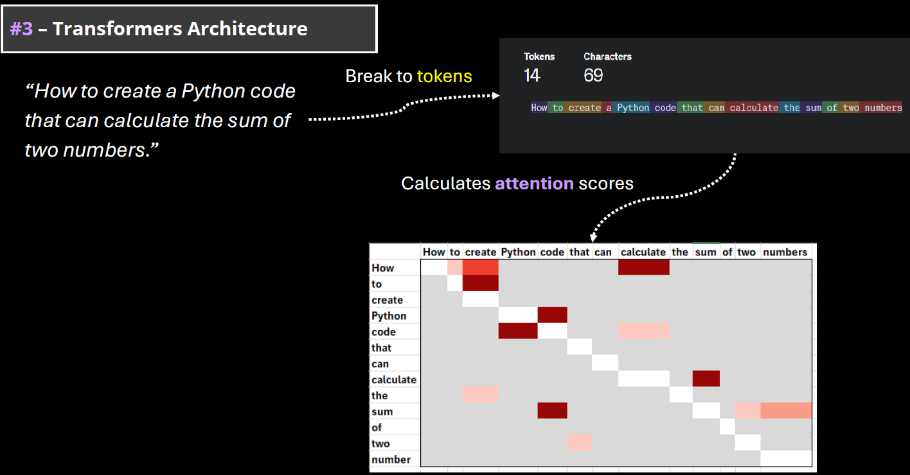

#### WHY TRANSFORMERS MATTER FOR GENERATIVE AI?

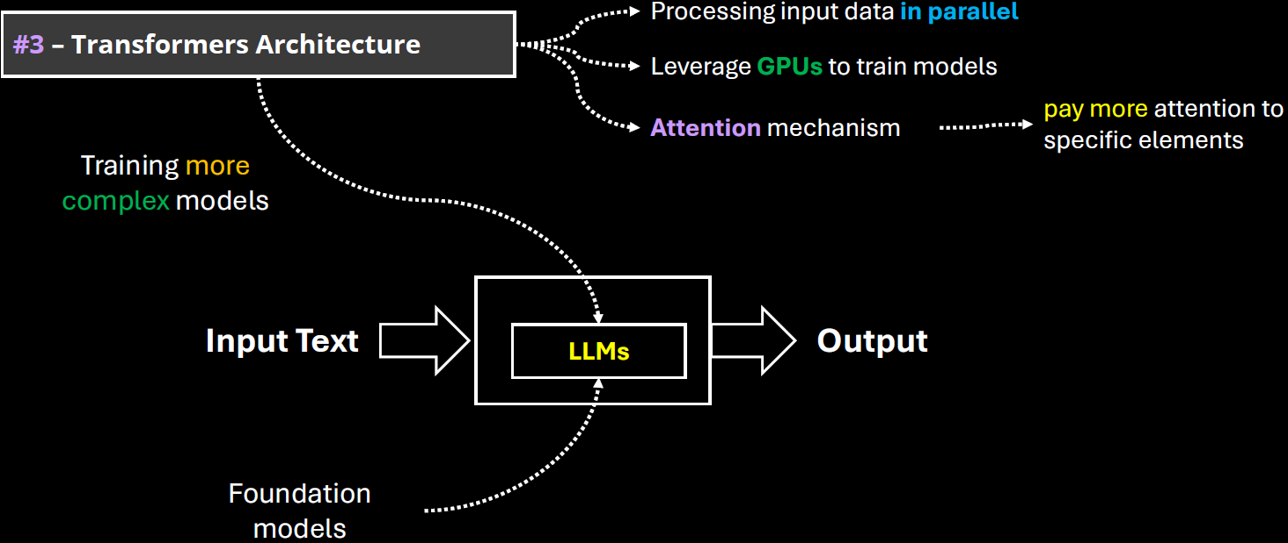

* The power of generative AI is based on the capabilities to digest and understand the human language. In machine learning terminology, it is called natural language processing(NLP).
* **Transformer Architecture is helping to train very complex models that can handle the human language. They are called LLMs (large language models)**
* Note: Training an LLM model requires huge amount of data and computing resources.

## FOUNDATION MODEL

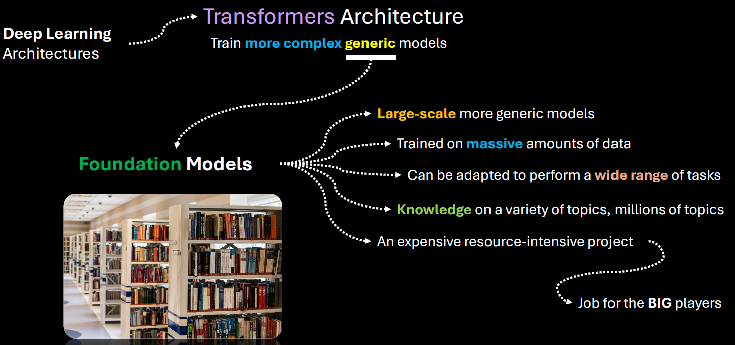

* **Foundation models** are large-scale machine learning models trained on vast amounts of data that can be adapted to a wide range of tasks.
* Training foundation models is expensive and resource-intensive which requires massive data collection, storage, and processing capabilities.
* Needs advanced hardware, software infrastructure, and skilled teams.
* Big tech companies like Google, Microsoft, and Amazon have the resources to train such models.
* **Popular example**: GPT, the foundation model behind OpenAI’s ChatGPT, trained on vast amounts of data

### KEY CHARACTERISTICS

1. **Scale**:  
   Foundation models are typically trained on massive datasets using billions (or even trillions) of parameters. Examples include GPT (like me), BERT, and CLIP.
2. **Generalization**:  
   They are not trained for a single task. Instead, they learn general patterns in data, which allows them to be fine-tuned or prompted for many different tasks—like translation, summarization, image recognition, or even coding.
3. **Multimodal Capabilities**:  
   Some foundation models can handle multiple types of data—like text, images, audio, or video—at the same time. For example, OpenAI’s CLIP can understand both images and text.
4. **Transfer Learning**:  
   Once trained, these models can be adapted to new tasks with relatively little additional data or training, making them highly efficient for downstream applications.

EXAMPLES OF FOUNDATION MODELS

* **GPT (Generative Pre-trained Transformer)** – for natural language understanding and generation.
* **BERT (Bidirectional Encoder Representations from Transformers)** – for understanding the context of words in text.
* **DALL·E** – for generating images from text prompts.
* **CLIP** – for connecting images and text.
* **Whisper** – for speech recognition.

ABOUT GPT

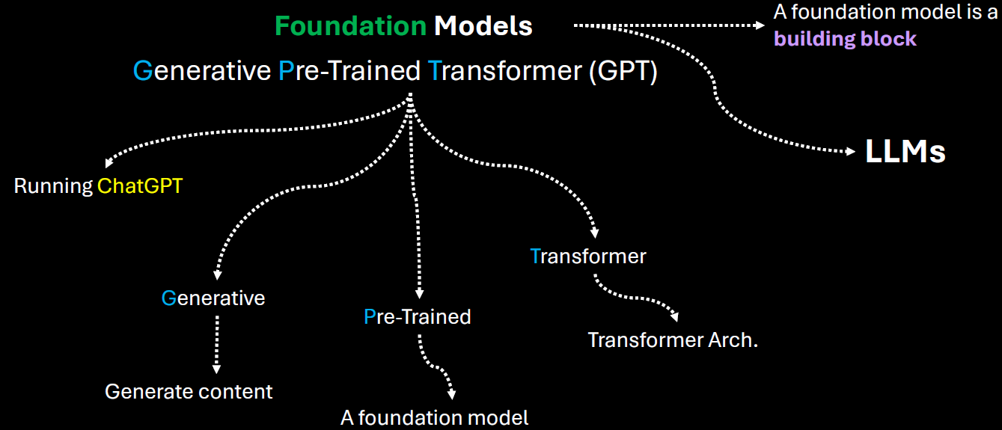

|  |  |
| --- | --- |
| **Generative** | It means that the model can generate content based on the input |
| **Pre-trained** | This model was trained on a large amount of data from diverse sources such as websites, books and articles. |
| **Transformer** | That's the internal architecture of the model, which is becoming the de facto architecture for creating foundation models. |

* Users can directly interact with the model using simple text as a prompt, ask a question and get an answer.
* Given this kind of versatility of a foundation model, smaller players, like medium sized companies or startups can leverage those foundation models developed or and provided by the big players. Hence - Instead of investing millions of dollars in training such models from scratch, they can adapt an existing foundation model for a fraction of that amount and introduce new AI based products more quickly.
* There are many types of foundation models, some focused-on handling natural language processing. Some of them are focused on computer vision tasks like image and video generation, speech recognition etc.
* One of the core foundation model types is for natural language processing. They are called LLMs

## APPLICATION OF GEN-AI

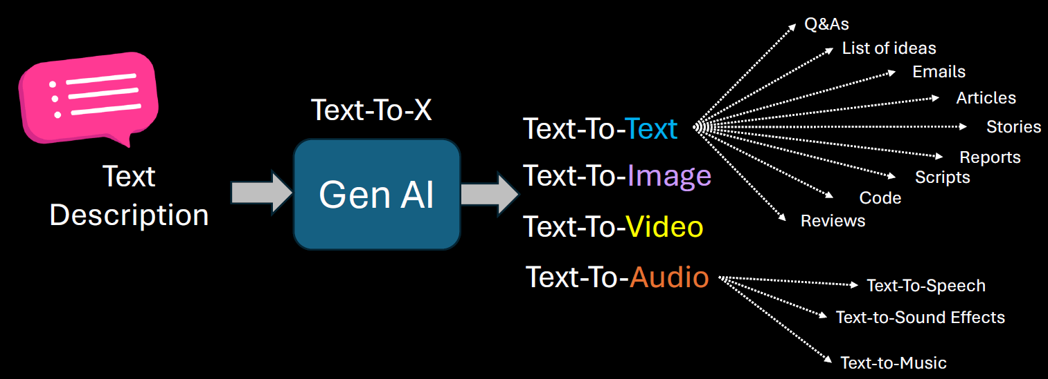

### GEN-AI USE CASES

* 1. Brainstorm Assistant
  2. Summarization
  3. Code Generation
  4. Text Enhancement(e.g. to check for grammatical mistake like copilot in outlook)
  5. Image Generation

## GEN-AI LIMITATIONS & CHALLENGES

**PROMPT SENSITIVITY**

* Generative AI models are highly sensitive to how a prompt is phrased. Small changes in wording can lead to significantly different outputs.
* This can make it difficult to get consistent or desired results without careful prompt engineering.
* **Example:** Asking "Explain climate change simply" vs. "What causes climate change?" may yield different levels of detail or focus.

**KNOWLEDGE CUTOFF**

* Most generative AI models are trained on data available up to a certain point in time. They do not have real-time awareness or access to events or developments after their training cutoff.
* **Implication:** They cannot provide accurate information about recent events, new technologies, or updated regulations unless connected to live data sources.

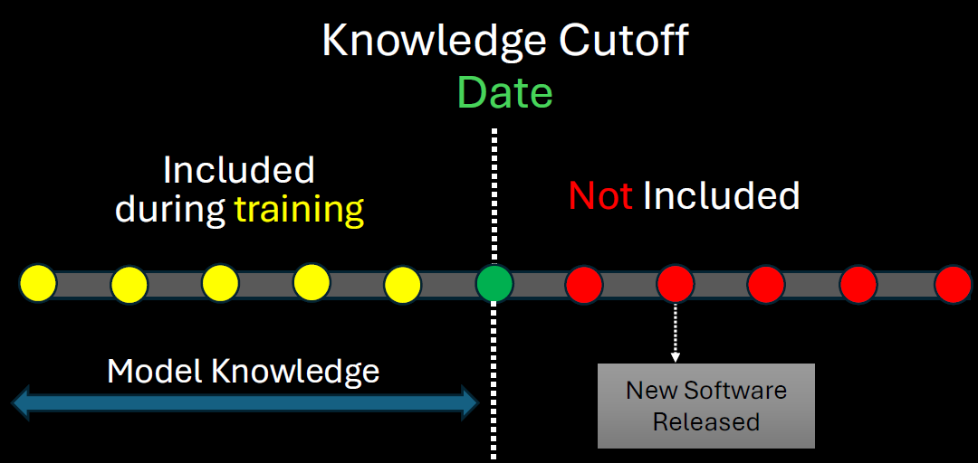

The solution to this to

1. Retrain the model after regular interval of time
2. Connect the model with online tools

**IT IS NOT DETERMINISTIC**

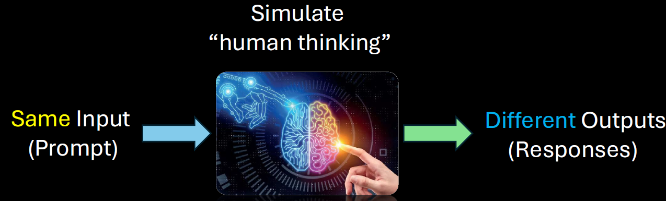

Generative AI is **probabilistic**, not deterministic. This means the same prompt can produce different outputs each time it's run.

**Implication:** This variability can be useful for creativity but problematic for tasks requiring consistency and repeatability.

**STRUCTURED DATA**

* Generative AI struggles with tasks that require precise manipulation of structured data (like databases, spreadsheets, or complex logic).
* **Example:** It may misinterpret or incorrectly summarize tabular data or fail to follow strict formatting rules.

**HALLUCINATIONS**

* AI models can "hallucinate" — confidently generating false or misleading information that sounds plausible.
* **Example:** Citing non-existent research papers or inventing facts in a historical summary.

**LACK OF COMMON SENSE**

* Despite being trained on vast data, generative AI lacks **true understanding** or **common-sense reasoning**. It may fail at tasks that require intuitive knowledge or real-world logic.
* **Example:** It might suggest putting metal in a microwave or confusing cause and effect in a scenario.

**BIAS AND FAIRNESS**

* AI models can reflect and even amplify biases present in their training data. This can lead to unfair, offensive, or discriminatory outputs.
* **Example:** Gender or racial bias in job recommendations or stereotypical characterizations in generated content.

**DATA PRIVACY, SECURITY, AND MISUSE**

* Generative AI can inadvertently expose sensitive information if trained on private data. It can also be misused for harmful purposes like generating fake news, phishing emails, or deepfakes.
* **Concerns:**
  + **Privacy:** Leaking personal or proprietary data.
  + **Security:** Being used to craft convincing scams.
  + **Misuse:** Generating harmful or misleading content.

# FEATURE SCALING

Feature scaling **transforms the values of features to be on a similar scale**, typically to improve model performance and training stability.

We can understand feature scaling using the example below. Note: ***Feature scaling is always applied at column level***

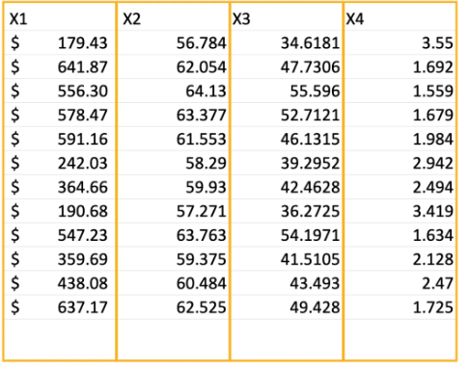

There are 2 main techniques of feature scaling

1. **NORMALIZATION**
2. **STANDARDIZATION**

## NORMALIZATION

|  |  |
| --- | --- |
|  | * The normalization value lies between the closed interval of [0;1] |

|  |  |  |
| --- | --- | --- |
| **X1 (Price)** | **X-XMIN** | **Normalized Value(X1)** |
| $179.43 | $0.00 | 0.00 |
| $641.87 | $179.43 | 0.39 |
| $556.30 | $376.87 | 0.814959779 |
| $578.47 | $116.03 | 0.250908226 |
| $591.12 | $411.69 | 0.890256033 |
|  |  |  |
| X1-MAX |  | $641.87 |
| X1-MIN |  | $179.43 |
| X1MAX - X1MIN |  | **$462.44** |

## STANDARDIZATION

|  |  |  |
| --- | --- | --- |
|  | µ | Average |
|  | Standard Deviation |
| * The value is lies in closes interval of [-3,3] * If data has some outliers – it will exist outside this range | |

## EXAMPLE - NORMALIZATION

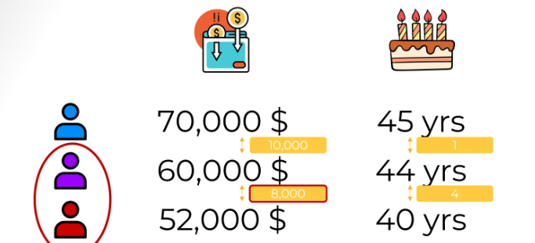

1. Let's imagine we have a data set where we have two columns, annual income of a person and their age of

a blue, purple and red person.

1. **We must identify whether the purple person is like a “red” person or “blue” person . This is the task of clustering data. For that we need to do normalization of data as the units of the data is not uniform**

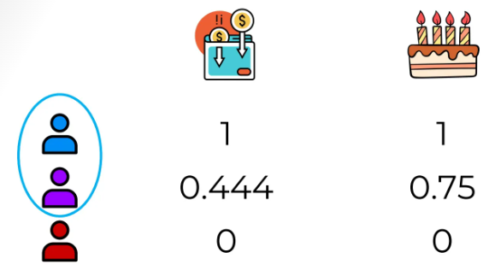

1. After normalizing, our values will look like above. Hence with the normalized data – From salary column perspective. The purple person is almost right in the middle between the red and the blue people(0.44), whereas in the age column, the purple person is closest to the blue person.

|  |
| --- |
| Scikit-learn (also written as scikit-learn or sklearn) is a powerful and widely used open-source machine learning library for the Python. It provides simple and efficient tools for:  🔍 Key Features   * Classification: Identifying which category an object belongs to (e.g., spam detection). * Regression: Predicting a continuous-valued attribute (e.g., house prices). * Clustering: Grouping similar data points (e.g., customer segmentation). * Dimensionality Reduction: Reducing the number of features (e.g., PCA). * Model Selection: Comparing, validating, and choosing parameters and models. * Preprocessing: Feature extraction, normalization, and transformation.   🧰 Built On  Scikit-learn is built on top of:   * NumPy: For numerical operations. * SciPy: For scientific computing. * Matplotlib: For plotting (indirectly used). * joblib: For model persistence and parallel processing. |

# TRAINING ML MODELS

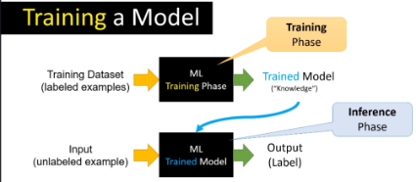

1. As part of the prerequisite of most machine learning projects, we need a training data set. A training data set is a large group of labeled examples. A machine-learning system is going to learn patterns inside the training data set and store that knowledge in something that is called a **model**.
2. This model is supposed to define as close as possible the relationship between features and the target label. In a common type of machine learning method called "supervised learning" the way to create this kind of model is based on analyzing a large group of labeled examples.
3. Once we have trained our model with those labeled examples, we can use that trained model to predict the label on unlabeled examples.

## LIFECYCLE

The lifecycle of a model in a machine learning system, we have two main phases

1. **TRAINING PHASE (LEARNING PHASE):** The main idea is to utilize or use some learning algorithms that will build the model using the training data set.
2. **INFERENCE PHASE (LEARNING PHASE):** In machine learning inference means applying the trained model in an actual machine learning system working in a production environment for making ongoing predictions.

## FEATURE ENGINEERING

# TYPES OF ML MODELS

1. **TRADITIONAL MODEL**
2. **REPRESENTATIONAL ML MODEL**

## TRADITIONAL MACHINE LEARNING MODELS

These models rely on **manually engineered features** and are often simpler and more interpretable. They include:

**CHARACTERISTICS OF TRADITIONAL ML MODEL**

1. Require **feature extraction** and **preprocessing** by humans.
2. Perform well on **structured data** (like tables, spreadsheets).
3. Easier to interpret and debug.
4. Often faster to train and require less data.

**EXAMPLES**

* **Linear Regression**
* **Logistic Regression**
* **Decision Trees**
* **Random Forests**
* **Support Vector Machines (SVM)**
* **K-Nearest Neighbors (KNN)**
* **Naive Bayes**

## REPRESENTATIONAL (OR REPRESENTATION LEARNING) MODELS

Representation ML based systems figure out by themselves what features to pay attention to

**CHARACTERISTICS OF REPRESENTATIONAL ML MODEL**

* Learn **significant features from the underlying data**
* Often based on **deep learning** architectures.
* Require large datasets and computational power.
* Less interpretable but more powerful for complex tasks.

**EXAMPLES:**

* **Neural Networks (NNs)**
* **Convolutional Neural Networks (CNNs)** – for images
* **Recurrent Neural Networks (RNNs)** – for sequences
* **Transformers** – for text and more
* **Autoencoders**
* **Self-supervised learning models**

# CHOOSING THE RIGHT ML SOLUTION

Broad Categories of Machine Learning Problems

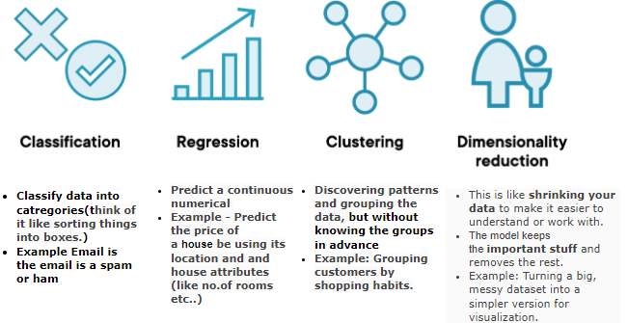

# TYPES OF MACHINE LEARNING

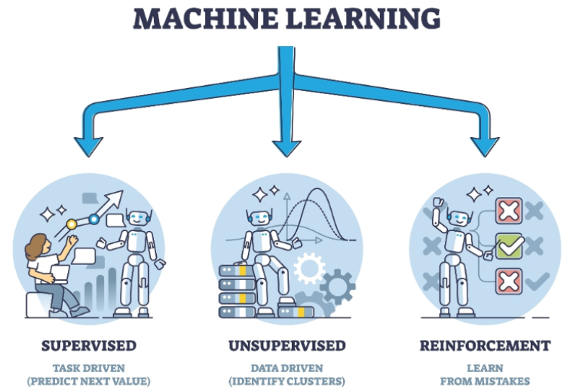

1. **SUPERVISED LEARNING MODELS**
   1. In supervised learning, for training data set that we feed in the features along with the labels(output)
2. **UNSUPERVISED LEARNING MODELS**:
   1. In unsupervised learning – we don’t know what the output will be, hence we cannot provide labels in training data
   2. Here we just want the model to split our data into different groups or clusters.

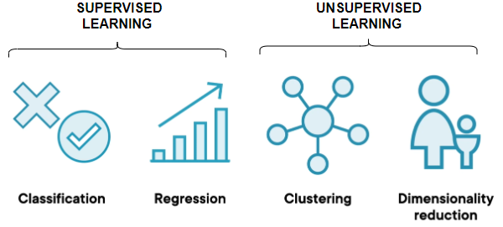

1. **REINFORCEMENT LEARNING MODELS**:
   1. These models learn through interaction with an environment. They receive feedback in the form of rewards or penalties, allowing them to learn optimal strategies for decision-making.
   2. Example:
      1. Let's take the example where we trying to teach a system how to play a game of chess against a human. So now, instead of we feeding in data about the different chess moves, we ask the model to play against a human.
      2. Hence, the system would go ahead and make a set of moves, and let's say it loses. So now it understands that if it performs set of actions, it results in a loss, then the next time around it will go and change its actions.
      3. It'll keep on doing this, so it's performing reinforcement of its actions. At the end when it does win a game, that’s the reward. So now it understands that based on certain set of actions that it takes, it's going to get a reward.

## SUPERVISED LEARNING

* The name supervised learning originates from the idea that training a machine while using this type of approach is like how humans are learning under the supervision of a teacher.
* Example - In regular school class, we have a group of students and a teacher. During a lecture about some specific topic, the teacher will provide several examples while teaching something. The students will use those examples to analyze and memorize them, something that will help them to extract the patterns from those examples. At a later stage, based on the information provided, the students will be able to solve similar problems. Overall, the teacher decided what kind of examples to present and how many, he or she basically supervised the learning process.
* **In supervised learning, we train machines by providing them with a set of examples, each provided example is a pair consisting of an input object and the desired output value for that object, it’s called label data set.**

|  |  |
| --- | --- |
|  | * **"X" is the input into the machine which can be a group of values called "features".** * **"Y" is the output of that machine, the target value.** * **Functions with the input x are basically some mathematical transformation function or mapping function discovered by the algorithm doing the training process** |

**NOTE: In Supervised Machine learning – the model tries to find the mapping function to map the input (feature) and output(label)**

|  |  |  |  |  |  |  |  |  |
| --- | --- | --- | --- | --- | --- | --- | --- | --- |
| **RELATION BETWEEN MAPPING FUNCTION AND ML ALGORITHM**  **WHAT IS A MAPPING FUNCTION?**   * Think of a mapping function as a recipe or rule that tells us how to turn input into output. * In machine learning, this function is what the algorithm is trying to learn from data.   **REAL-WORLD EXAMPLE: PREDICTING HOUSE PRICES:** Let’s say we want to predict the price of a house based on its size.   * Input (X): Size of the house (e.g., 1000 sq ft) * Output (Y): Price of the house (e.g., ₹50 lakhs)   The ML algorithm’s job is to learn a function like:  **Price = f(Size)**  This function could be:   * A straight line (if price increases steadily with size) * A curve (if price increases faster for bigger houses)   **HOW ML ALGORITHM USES THE MAPPING FUNCTION?**   1. **Step 1**: We give it data: Sizes and prices of many houses. 2. **Step 2**: It finds a pattern: Learns the best function (mapping) that connects size to price. 3. **Step 3**: We use it to predict: For a new house size, it uses the function to predict the price.   Example in Simple Terms (Training Data)   |  |  | | --- | --- | | Size (sq ft) | Price (₹ lakhs) | | 1000 | 50 | | 1500 | 75 | | 2000 | 100 |  * The ML algorithm might learn: **Price = 0.05 X Size** * So, for a 1200 sq ft house: **Price = 0.05 X 1200 = ₹60** * A mapping function is the rule that connects input to output. * An ML algorithm learns this rule from data. * Once learned, it can make predictions on new data.   **Here's a simple chart that shows how a machine learning algorithm learns a mapping function from house size to price:**     * *Blue dots: Real data points (house size vs. price).* * *Red line: The learned function (Price = 0.05 × Size), which the ML algorithm uses to make predictions***.**   **This is a basic example of how ML finds a pattern (a mapping function) in data and uses it to predict outcomes.** |

Two typical tasks performed by Supervised Learning

1. **CLASSIFICATION**
2. **REGRESSION**

### CLASSIFICATION (BINARY CLASSIFICATION)

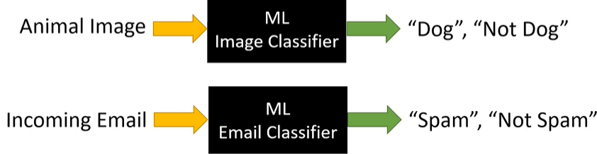

**Classification** is a type of supervised learning where the goal is to **predict a category or class**. Instead of predicting a number (like in regression), classification predicts a **label**.

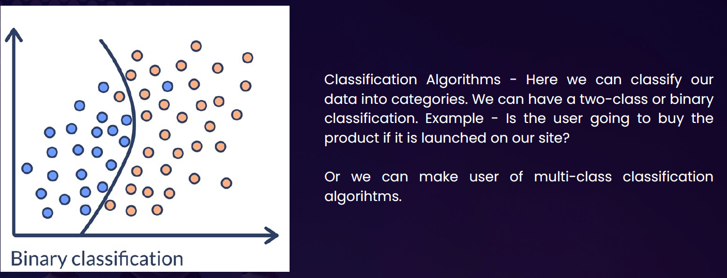

**Real-Life Example: Email Spam Detection**

Imagine if we have a bunch of emails, and each one is labeled as either:

* **Spam**
* **Not Spam**

We train a machine learning model with this data. The model learns patterns like:

1. Emails with “win money” → likely spam
2. Emails from your contacts → likely not spam

Once trained, the model can classify **new emails** as spam or not spam.

**Other Examples of Classification**

|  |  |
| --- | --- |
| Problem | Classes (Labels) |
| Disease diagnosis | Sick / Healthy |
| Image recognition | Cat / Dog / Bird |
| Customer feedback sentiment | Positive / Negative / Neutral |
| Loan approval | Approved / Rejected |

#### MULTICLASS CLASSIFICATION

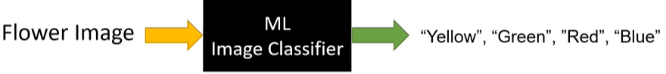

Multiclass classification is when a machine learning model predicts **one label out of three or more possible categories**.

|  |  |
| --- | --- |
| **Problem** | **Classes (Labels)** |
| Handwritten digit recognition | 0 to 9 |
| Animal image classification | Cat / Dog / Bird / Horse |
| Exam grading | A / B / C / D / F |

* SVM(Support Vector Machines) are one such classification ML Model

### REGRESSION ALGORITHM

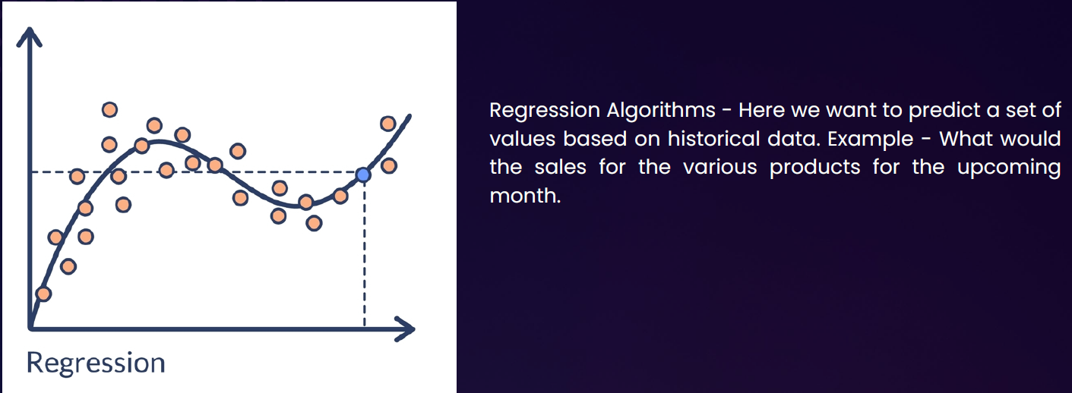

* **Regression** is a type of **supervised learning** where the goal is to **predict a continuous value** (a number) based on input data.

**Real-World Example: Predicting House Prices**

|  |  |  |  |  |  |  |  |  |  |  |  |  |  |  |  |  |  |  |  |  |  |
| --- | --- | --- | --- | --- | --- | --- | --- | --- | --- | --- | --- | --- | --- | --- | --- | --- | --- | --- | --- | --- | --- |
| Imagine a real estate agent and want to **predict the price of a house** based on certain features like:   * Size of the house (in square feet) * Number of bedrooms * Location * Age of the house | You collect data from past house sales. Each row in your dataset looks like this:   |  |  |  |  |  | | --- | --- | --- | --- | --- | | **Size (sqft)** | **Bedrooms** | **Age (years)** | **Location Score** | **Price (₹)** | | 1200 | 3 | 5 | 8 | 45,00,000 | | 1500 | 4 | 2 | 9 | 60,00,000 | | 1000 | 2 | 10 | 6 | 35,00,000 | |

* Now, we can train a **regression model** using this data. The model learns the relationship between the features and the price. Later, when we get a new house with known features but unknown price, the model can **predict the price**.

Great question! Let's break it down simply.

**What Does "Predict a Continuous Value" Mean?**

A **continuous value** is a number that can be **any value within a range**, not just fixed categories.

So, when we say **"predict a continuous value"**, we mean the model is trying to **guess a number** — not a label like "yes/no" or "cat/dog", but something like:

**Real-Life Examples**

|  |  |  |
| --- | --- | --- |
| **Problem** | **Input Features** | **Output (Continuous Value)** |
| Predict house price | Size, location, age | ₹50,00,000 |
| Predict temperature | Date, time, humidity | 32.5°C |
| Predict height of a child | Age, gender, parents' height | 145.2 cm |
| Predict fuel efficiency | Engine size, weight, speed | 18.7 km/l |

In each case, the **output is a number** that can vary smoothly — not just a fixed set of options.

**GRAPHICAL REPRESENTATION**

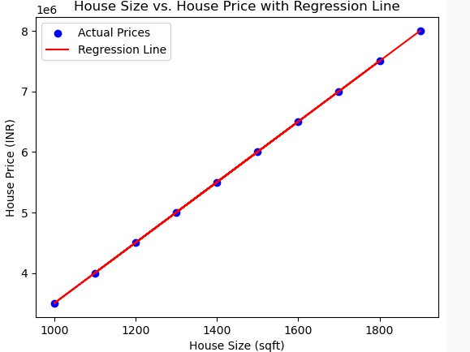

* Each dot represents a house.
* The x-axis is the size of the house (in square feet).
* The y-axis is the price of the house (in INR).
* The pattern shows that as house size increases, the price also tends to increase — this is the kind of relationship a regression model learns.
* Red line: The regression line — this is the model's prediction of house price based on size.
* The most common form of regression analysis is linear regression

#### LINEAR REGRESSION

* **Linear regression** is a fundamental concept in statistics and machine learning used to model the relationship between a **dependent variable** (target) and one or more **independent variables** (predictors or features).
* **Key Idea:** Linear regression assumes that there is a **linear relationship** between the input (X) and output (Y), meaning:

|  |  |
| --- | --- |
| **Y = aX + b + error** | * **Y** is the dependent variable (what we want to predict), * **X** is the independent variable (input), * **a** is the slope (how much Y changes with X), * **b** is the intercept (value of Y when X = 0), * **error** is the difference between the predicted and actual value. |

##### TYPES OF LINEAR REGRESSION

1. **Simple Linear Regression**: 1 independent variable: **Y = aX + b**
2. **Multiple Linear Regression**: more than 1 independent variable **Y = a1X1 + a2X2 + ... + anXn + b**

|  |
| --- |
| **Goal: Find the best values of a and b so that the predicted Y values are as close as possible to the actual Y values — usually by minimizing the mean squared error (MSE) between them.** |

**Other Applications:**

* Predicting sales based on ad spend
* Estimating house prices based on size, location, etc.
* Forecasting trends over time

##### EXAMPLE OF LINEAR REGRESSION

|  |  |  |
| --- | --- | --- |
| Problem: You have data showing how much a student studies (in hours), and their exam score. You want to predict the score based on study time. | **Study Hours (X)** | **Exam Score (Y)** |
| 1 | 50 |
| 2 | 55 |
| 3 | 65 |
| 4 | 70 |
| 5 | 75 |

**Goal:** Find a line Y = aX + b that best fits this data.

**Step 1: Plot the data :** If you plot X and Y on a graph, you'll notice a roughly straight-line trend.

**Step 2: Apply linear regression :** Using Python (with scikit-learn), you can fit a model:

|  |  |
| --- | --- |
| **from sklearn.linear_model import LinearRegression**  **import numpy as np**  **# Data**  **X = np.array([[1], [2], [3], [4], [5]]) # 2D array for sklearn**  **Y = np.array([50, 55, 65, 70, 75])**  **# Model**  **model = LinearRegression()**  **model.fit(X, Y)**  **# Coefficients**  **slope = model.coef_[0]**  **intercept = model.intercept_**  **print(f"Model: Y = {slope:.2f}X + {intercept:.2f}")** | **Output:**  Model: Y = 6.5X + 43.0  This means:   * For every extra hour studied, score increases by ~6.5 * If a student studies **0 hours**, expected score = 43   **Prediction Example:**  Predict the score if a student studies for 6 hours:  **model.predict([[6]]) # Output: ~82.0**  So, **predicted score = 82**. |

## UNSUPERVISED LEARNING

* **Unsupervised learning** is a type of machine learning where the model learns from data **without any labels**.
* It tries to find **patterns, structures, or groupings** in the data on its own.

##### Examples

Imagine we have a bunch of photos of animals, but we don’t tell the model which ones are cats, dogs, or birds. The model looks at the photos and **groups similar ones together** — maybe all the cats in one group, dogs in another, and so on.

Common Use Cases

|  |  |
| --- | --- |
| Use Case | Description |
| Customer Segmentation | Grouping customers based on behavior or preferences. |
| Market Basket Analysis | Finding which products are often bought together. |
| Anomaly Detection | Spotting unusual patterns (e.g., fraud detection). |
| Document Clustering | Grouping similar news articles or research papers. |
| Image Compression | Reducing image size by identifying patterns in pixels. |

Popular Algorithms

* **K-Means Clustering**
* **Hierarchical Clustering**
* **DBSCAN**
* **Principal Component Analysis (PCA)**
* **Autoencoders**

## SUPERVISED V/S UN-SUPERVISED LEARNING

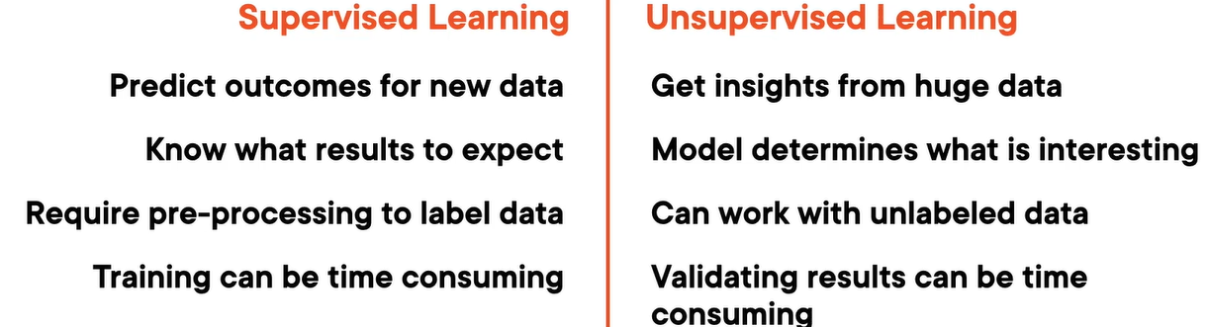

# SPECIALIZED ML PROBLEMS

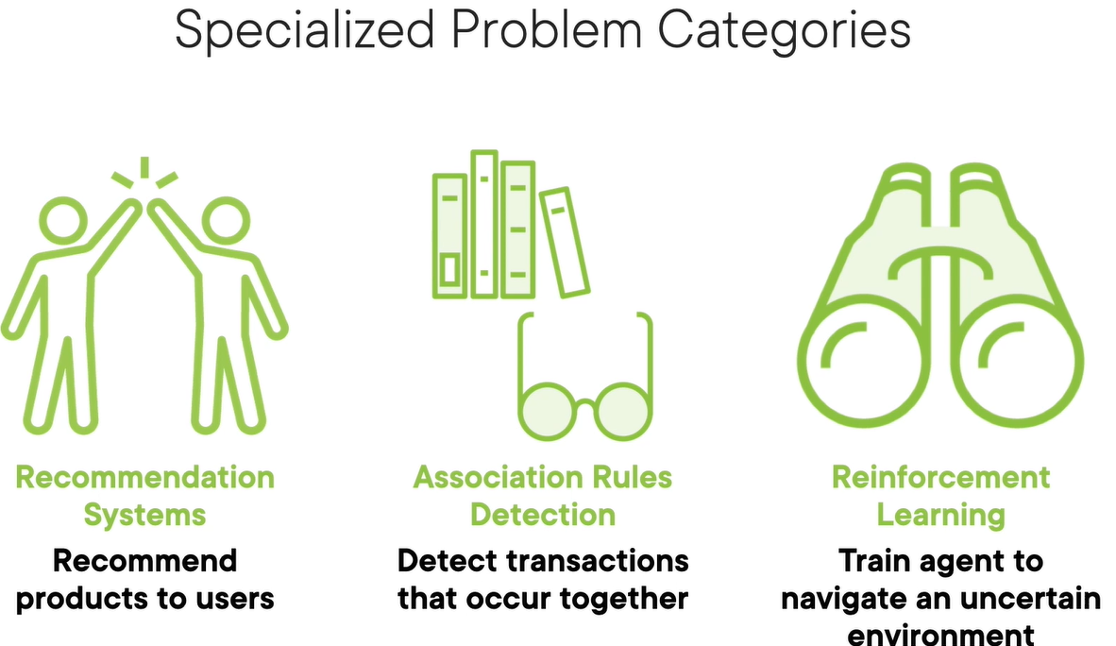

|  |  |
| --- | --- |
| Recommendation System | * Recommend products which user might lik e * Typically used in E-commerce application |
| Association Rule Detection | * Detect transaction that can occur together * For example – **"If a customer buys Bread and Butter, they are likely to buy Milk** |
| Reinforcement Learning | * Robots learn to walk. |

## RECOMMENDATION SYSTEMS

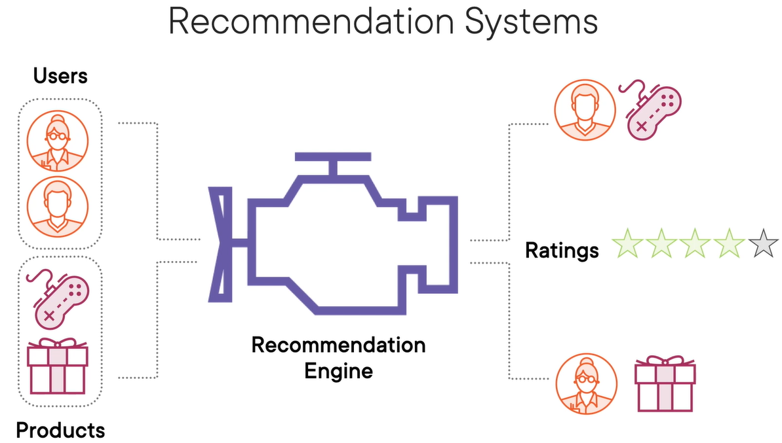

* A **Recommendation System** is a type of information filtering system that predicts and suggests items a user might like based on various data inputs.
* These systems are widely used in platforms like Netflix, Amazon, Spotify, and YouTube.

### TYPES OF RECOMMENDATION SYSTEMS

#### CONTENT-BASED FILTERING

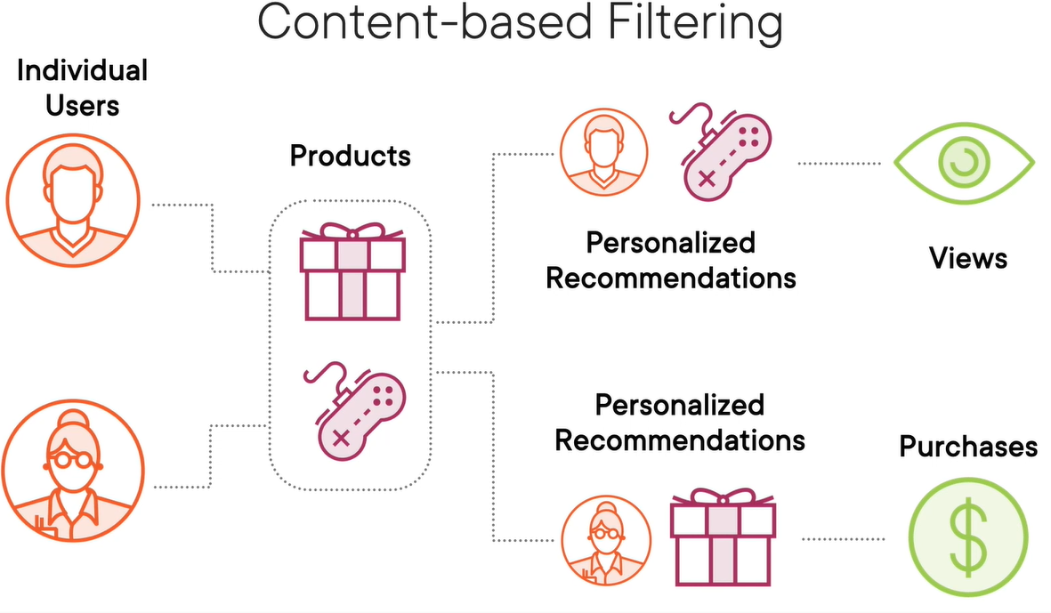

* For any typical e-commerce site has large number user. This user will have history of brought and viewed products
* Based on user’s history and product characteristics can used to figure out – user will like a product or not – based on which a product is recommended.
* Items are recommended based on user profile , product features or items similar to those the user liked in the past.
  + Other Typical Example Based on item features (e.g., genre, keywords). If we watched many action movies, it recommends more action movies.

#### COLLABORATIVE FILTERING

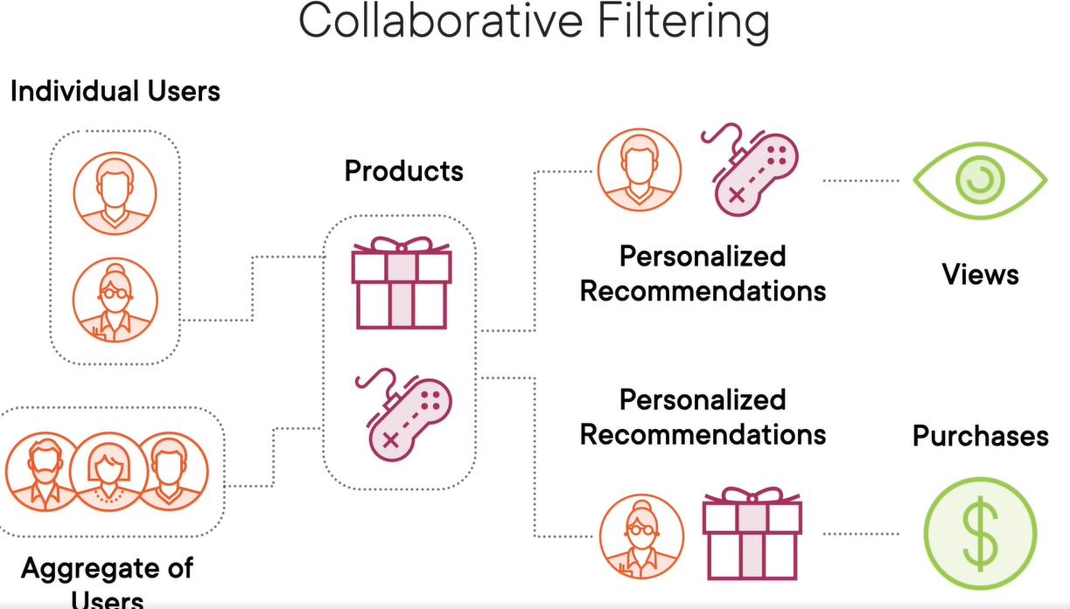

* In a typical ecommerce platform there are certain user who are buying product and other set of users who are buy, like and reviewing the same product. Collaborative filtering techniques make use of this information.
* Recommend items based on the preferences of similar users.
  + Two types:
    - **User-based**: "Users like you also liked…"
    - **Item-based**: "Users who liked this item also liked…"
  + Example: Amazon’s “Customers who bought this also bought…”

#### HYBRID SYSTEMS

* + Combine content-based and collaborative filtering.
  + More accurate and robust.

Example Scenario: Movie Recommendation

|  |  |  |  |  |  |  |  |  |  |  |  |  |  |  |  |  |
| --- | --- | --- | --- | --- | --- | --- | --- | --- | --- | --- | --- | --- | --- | --- | --- | --- |
| Let’s say a user has rated the following movies:   | **Movie** | **Genre** | **User Rating** | | --- | --- | --- | | Inception | Sci-Fi | 5 | | Interstellar | Sci-Fi | 5 | | The Notebook | Romance | 2 | | Titanic | Romance | 3 | | A **content-based system** might recommend more Sci-Fi movies like *The Matrix* or *Blade Runner*.  A **collaborative filtering system** might find other users who rated *Inception* and *Interstellar* highly and suggest movies they also liked. |

## ASSOCIATIONS RULES DETECTION

* **Association Rule Detection** is a data mining technique usually used to identify interesting relationships, patterns, or associations among a set of items in large datasets.
* It's commonly used in market basket analysis to find products that frequently co-occur in transactions.
* **It’s a rule based machine learning technique, where ML is used to create rules**
  + The rules are in the form “if x then y” e.g. If the shopping card has books its likely to contain stationaries
  + Association rule learning tries to identify strong rules which are supported by probability i.e. if the presence of “x” means there is high probability of “y”.
  + These strong rules can be extremely useful in
    - Recommendations
    - Cross-sell or Up-sell the produts

Key Concepts

* **Support**: How frequently an itemset appears in the dataset.
* **Confidence**: How often do items in Y appear in transactions that contain X.
* **Lift**: The ratio of observed support to that expected if X and Y were independent.

Example: Market Basket Analysis

Imagine a supermarket wants to analyze customer purchase behavior. Here's a sample dataset of transactions. **Goal: Find rules like "If a customer buys Bread and Butter, they are likely to buy Milk."**

|  |  |  |  |  |  |  |  |  |  |  |  |  |  |
| --- | --- | --- | --- | --- | --- | --- | --- | --- | --- | --- | --- | --- | --- |
| | Transaction ID | Items Bought | | --- | --- | | 1 | Milk, Bread, Butter | | 2 | Bread, Butter | | 3 | Milk, Bread | | 4 | Milk, Bread, Butter, Eggs | | 5 | Bread, Butter, Eggs | | Step-by-Step Rule Detection  Let’s say we want to evaluate the rule:**{Bread, Butter} ⇒ {Milk}**   1. Support = Transactions with Bread, Butter, and Milk / Total Transactions = 2 / 5 = 0.4 2. Confidence = Transactions with Bread, Butter, and Milk / Transactions with Bread and Butter = 2 / 3 = 0.67 3. Lift = Confidence / Support of Milk = 0.67 / 0.6 = 1.11   **Since Lift > 1, the rule suggests a positive association between {Bread, Butter} and {Milk}.** |

## REINFORCEMENT LEARNING

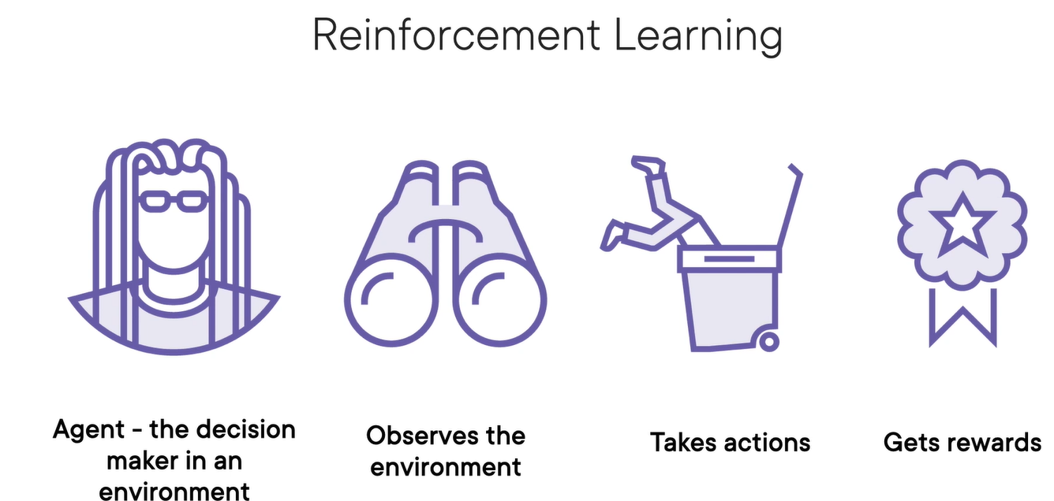

**Reinforcement Learning (RL)** is a type of machine learning where an agent learns to make decisions by interacting with an environment to maximize some notion of cumulative reward.

|  |
| --- |
| STEP TO TRAIN MODEL   * We train the agent in a computer simulation, which acts as a virtual sandbox for the real‑world environment. * Then, we fine tune the agent's behavior in a safe, real‑world environment to iron out any training issues. * Finally, we deploy the agent into the real world while we monitor its behavior and collect new data to further improve the model |

How It Works (The RL Loop)

|  |  |
| --- | --- |
|  | 1. The agent is the decision in an environment which has to constantly looking around and observe the **current state/environment**. The environment is completely new for Agent 2. It takes certain **actions** in the environment. 3. If these actions happen to be a right one agent will be rewarded or otherwise penalized. 4. The output of Reinforced learning is set of action rather than set of predictions 5. The algorithm that determines these action is called **policy** 6. Actions are optimized to earn rewards and avoid punishments |

Example: Game Playing (e.g., Tic-Tac-Toe)

1. **State**: Current board configuration.
2. **Action**: Place X or O in an empty cell.
3. **Reward**: +1 for win, -1 for loss, 0 for draw.
4. **Goal**: Learn a policy that maximizes the chance of winning.

Real-World Applications

1. **Robotics**: Teaching robots to walk or grasp objects.
2. **Finance**: Portfolio optimization.
3. **Healthcare**: Personalized treatment strategies.
4. **Games**: AlphaGo, OpenAI Five, etc.
5. **Recommendation Systems**: Dynamic content personalization.

# APPLYING ML IN COMPLEX DATA

|  |  |
| --- | --- |
| Applying ML To Text Data  (NLP) | We apply ML for text in following use-cases   * Sentiment analysis of reviews on a site * Spam filtering * Language Translation * Natural Language Processing |
| Applying ML To Image Data  (CNN - convolutional neural networks) | We apply ML for image in following scenarios   * Image Classification * Object Detection * Facial recognition * Visual Search Engines * Medical imaging |
| Applying ML To Speech Data | We apply ML for image in following scenarios   * Speech Recognition * Speech to text conversion * Personalized Voice Assistants |

## APPLYING ML TO TEXT DATA

Why Text Needs Preprocessing?

* ML models work with **numbers**, not raw text.
* Text must be **converted into numeric form** before feeding into a model.

Steps to Prepare Text for ML

Step 1: Treat each sentence as a **document**.

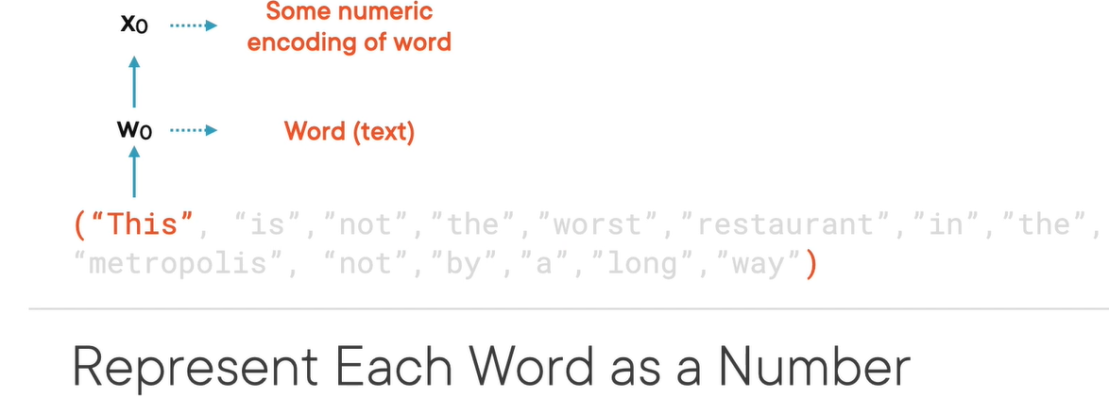

* **Step 2: Tokenize** the document into individual words.
* **Step 3: Numerically encode** each word (e.g., X₀, X₁, …, Xₙ).
* **Step 4:** Combine encoded words into a **tensor** (multi-dimensional array).

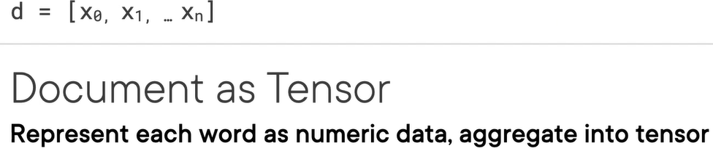

### ENCODING TECHNIQUES

**There are various techniques to encode the text to numbers**

#### ONE-HOT ENCODING

What is One-Hot Encoding?

* One-hot encoding is a technique to convert **text data into numerical format** so that it can be used in machine learning models.  
  Each **unique word** in the text is represented as a **binary vector**:
* 1 indicates the presence of the word.
* 0 indicates absence.

Example

|  |  |
| --- | --- |
| Let’s say we have a small corpus of 3 reviews: | **"Amazing movie"**  **"Worst movie ever"**  **"Two thumbs up"** |
| **Step 1: Build the Vocabulary** | All unique words across the reviews:  ["Amazing", "movie", "Worst", "ever", "Two", "thumbs", "up"] |
| **Step 2: One-Hot Encode Each Review** | * **One-hot encoding** is like giving each word a unique ID in binary form * Each position in the vector corresponds to a word in the vocabulary.  | **Review** | **One-Hot Vector** | | --- | --- | | Amazing movie | [1, 1, 0, 0, 0, 0, 0] | | Worst movie ever | [0, 1, 1, 1, 0, 0, 0] | | Two thumbs up | [0, 0, 0, 0, 1, 1, 1] | |

Limitations

* **No word order** is preserved.
* **No semantic meaning** is captured (e.g., “good” and “great” are unrelated).
* Vectors can become **very large** with big vocabularies.

#### FREQUENCY-BASED ENCODING

What is Frequency-Based Encoding?

A method to convert text into numerical form by **counting how often words appear** in documents or across a corpus.

---

### 🔸 **Common Techniques**

#### 1. **Count Vector**

- Each document is represented as a vector of **word counts**.

- Simple but doesn’t account for word importance across documents.

#### 2. **TF-IDF (Term Frequency–Inverse Document Frequency)**

- Balances **how often a word appears in a document** with **how rare it is across all documents**.

- Formula:

$$ \text{TF-IDF}(i, j) = \text{TF}(i, j) \times \text{IDF}(i) $$

- **TF(i, j)**: Frequency of word *i* in document *j*.

- **IDF(i)**: Inverse frequency of word *i* across all documents.

#### 3. **Co-occurrence Matrix**

- Captures how often words appear **together** in a context window.

- Useful for understanding **word relationships**.

---

### 📝 **Example (TF-IDF)**

Corpus:

- Doc 1: "The movie was awesome"

- Doc 2: "The movie was terrible"

- **TF** for "movie" in Doc 1 = 1

- **IDF** for "movie" = low (appears in both docs)

- **TF-IDF** for "awesome" = high (unique to Doc 1)

---

### ✅ **Advantages**

- Captures **importance** of words.

- More informative than one-hot encoding.

### ⚠️ **Limitations**

- Still **ignores word order**.

- Doesn’t capture **semantic meaning** like embeddings.

#### PREDICTION-BASED ENCODING (WORD EMBEDDINGS)

* Learns **semantic relationships** between words.
* Words used in similar contexts have **similar vectors**.
* Examples: Word2Vec, GloVe, FastText.
* Captures meaning like:
  + *King – Man + Woman ≈ Queen*
  + *Paris : France :: London : England*
* Requires **large corpus** and **unsupervised learning**.

**🔹 Key Takeaways**

* Text must be **numerically encoded** for ML models.
* Choose encoding based on:
  + Simplicity → One-Hot
  + Importance → TF-IDF
  + Meaning → Word Embeddings

## APPLYING ML TO IMAGE DATA

## APPLYING ML TO SPEECH DATA

# MACHINE LEARNING ALGORITHMS CLASSIFICATION

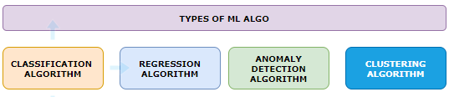

## ANOMALY DETECTION ALGORITHM

* This is used to detect if data deviates from the norm
* Example: used to detect fraudulent credit card purchase

## CLUSTERING ALGORITHM

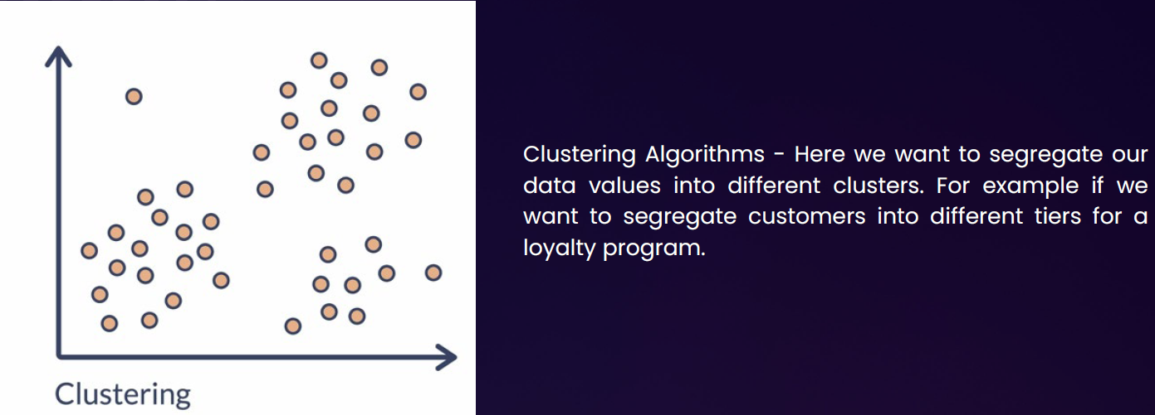

# DATA PRE-PROCESSING USING PYTHON

|  |  |
| --- | --- |
|  | * In this example we will perform data preprocessing step on this following data * It’s a user profile data – of an ecommerce website with a flag which says whether user has made purchase or not! * As a data processing step – we create two entities –  1. The first is **the matrix of features**, which contains separately these three columns (country, age, salary.) 2. And second is the dependent variable vector, which is last column(“Purchased”), because that's the column we want to predict.   *Note : This is exactly what we must do in this first data pre-processing phase.* |

|  |  |
| --- | --- |
| Step 1: Importing the libraries | import numpy as np import matplotlib.pyplot as plt import pandas as pd |
| Step 2: Importing the dataset | dataset = pd.read_csv('Data.csv') X = dataset.iloc[:, :-1].values y = dataset.iloc[:, -1].values  OUTPUT  [['France' 44.0 72000.0]  ['Spain' 27.0 48000.0]  ['Germany' 30.0 54000.0]  ['Spain' 38.0 61000.0]  ['Germany' 40.0 nan]  ['France' 35.0 58000.0]  ['Spain' nan 52000.0]  ['France' 48.0 79000.0]  ['Germany' 50.0 83000.0]  ['France' 37.0 67000.0]]  ['No' 'Yes' 'No' 'No' 'Yes' 'Yes' 'No' 'Yes' 'No' 'Yes'] |
| Step 3: Missing Data   * For missing data, we can make use of Python library Scikit-learn. It is an open-source machine learning library built on top of **NumPy**, **SciPy**, and **matplotlib**. * It provides simple and efficient tools for data mining and data analysis. * For example - For missing salary - We will replace the missing salary with average salary in the column   **from sklearn.impute import SimpleImputer**  **imputer= SimpleImputer(missing_values=np.nan, strategy='mean') imputer.fit(X[:, 1:3]) # Assuming columns 1 and 2 have missing values X[:, 1:3] = imputer.transform(X[:, 1:3]) # Transform the data to fill missing values**   * SimpleImputer from scikit-learn to fill missing values (NaN) in specific columns of the feature matrix X with the mean of each column. * It fits the imputer on columns 1 and 2 (indexing starts at 0), replaces missing values with the computed mean | |

Step 4: Encoding the categorial data

* Encoding categorical data is **crucial in machine learning** because most ML algorithms require **numerical input** to perform mathematical computations.

Common Encoding Techniques

|  |  |  |
| --- | --- | --- |
| Technique | Description | Best For |
| Label Encoding | Assigns A Unique Number To Each Category | Ordinal Data (E.G., "Low", "High") |
| One-Hot Encoding | Creates Binary Columns For Each Category | Nominal Data (E.G., "Red", "Blue") |
| Ordinal Encoding | Encodes Categories With Meaningful Order | Ordered Categories |
| Target Encoding | Replaces Categories With The Mean Of The Target Variable For Each Category | High-Cardinality Categorical Data |

Example

Suppose we have a column Fuel Type with values: ["Petrol", "Diesel", "Electric"]

* Label Encoding: Petrol → 0, Diesel → 1, Electric → 2 (May imply an order that doesn’t exist)
* One-Hot Encoding:

| Petrol | Diesel | Electric |
| --- | --- | --- |
| 1 | 0 | 0 |
| 0 | 1 | 0 |
| 0 | 0 | 1 |

Why Encode Categorical Data?

* ML Models Work with Numbers
  1. Algorithms like linear regression, decision trees, and neural networks **cannot interpret text** or labels directly. They need **numerical representations** to process the data.
* Preserves Information
  1. Encoding transforms categories into numbers **without losing the meaning** of the data. For example, converting "Red", "Blue", "Green" into numerical form allows the model to still distinguish between them.
* Improves Model Performance
  1. Proper encoding helps the model **understand relationships** between variables, which can lead to **better predictions** and **faster training**.
* Avoids Bias from Arbitrary Numbers
  1. Some encoding methods (like **One-Hot Encoding**) prevent the model from assuming an **ordinal relationship** where none exists.
  2. For example, assigning "Low", "Medium", "High" as 1, 2, 3 implies a ranking, which may or may not be appropriate.

CODE

Taking the example further will apply “Hot Encoding” of “County” column and “label encoding” to the “Purchased” column.

One Hot Encoding OF Country Column

|  |
| --- |
| from sklearn.preprocessing import OneHotEncoder  ct = ColumnTransformer(transformers=[('encoder', OneHotEncoder(),[0])],remainder='passthrough') X = np.array(ct.fit_transform(X)) # Apply one-hot encoding to the first column |

LABELLED Encoding OF Country Column

|  |
| --- |
| from sklearn.preprocessing import LabelEncoder  le = LabelEncoder() y = le.fit_transform(y) # Apply label encoding to the dependent variable |

EXAMPLE – CODING EXERCISE

Dataset

|  |  |  |  |  |  |  |  |  |  |  |  |
| --- | --- | --- | --- | --- | --- | --- | --- | --- | --- | --- | --- |
| PassengerId | Survived | Pclass | Name | Sex | Age | SibSp | Parch | Ticket | Fare | Cabin | Embarked |
| 2 | 1 | 1 | Cumings, Mrs. John Bradley (Florence Briggs Thayer) | female | 38 | 1 | 0 | PC 17599 | 71.2833 | C85 | C |
| 4 | 1 | 1 | Futrelle, Mrs. Jacques Heath (Lily May Peel) | female | 35 | 1 | 0 | 113803 | 53.1 | C123 | S |
| 7 | 0 | 1 | McCarthy, Mr. Timothy J | male | 54 | 0 | 0 | 17463 | 51.8625 | E46 | S |
| 11 | 1 | 3 | Sandstrom, Miss. Marguerite Rut | female | 4 | 1 | 1 | PP 9549 | 16.7 | G6 | S |
| 12 | 1 | 1 | Bonnell, Miss. Elizabeth | female | 58 | 0 | 0 | 113783 | 26.55 | C103 | S |
| 22 | 1 | 2 | Beesley, Mr. Lawrence | male | 34 | 0 | 0 | 248698 | 13 | D56 | S |

Coding Exercise 3: Encoding Categorical Data for Machine Learning

**1**: Import required libraries - Pandas, Numpy, and required classes for this task - ColumnTransformer, OneHotEncoder, LabelEncoder.

**2**: Start by loading the Titanic dataset into a pandas data frame. This can be done using the pd.read_csv function. The dataset's name is 'titanic.csv'.

**3**: Identify the categorical features in your dataset that need to be encoded. You can store these feature names in a list for easy access later.

**4**: To apply OneHotEncoding to these categorical features, create an instance of the ColumnTransformer class. Make sure to pass the OneHotEncoder() as an argument along with the list of categorical features.

**5**: Use the fit_transform method on the instance of ColumnTransformer to apply the OneHotEncoding.

**6**: The output of the fit_transform method should be converted into a NumPy array for further use.

**7**: The 'Survived' column in your dataset is the dependent variable. This is a binary categorical variable that should be encoded using LabelEncoder.

**8.**  Print the updated matrix of features and the dependent variable vector

|  |
| --- |
| # Importing the necessary libraries import pandas as pd import numpy as np from sklearn.compose import ColumnTransformer from sklearn.preprocessing import OneHotEncoder, LabelEncoder  # Load the dataset dataset = pd.read_csv("titanic.csv")  # Identify the categorical data categorical_features = ['Sex', 'Embarked', 'Pclass']  # Implement an instance of the ColumnTransformer class  ct = ColumnTransformer(transformers=[('encoder', OneHotEncoder(),categorical_features)],remainder='passthrough')  # Apply the fit_transform method on the instance of ColumnTransformer ct_fit = ct.fit_transform(dataset) # Apply one-hot encoding to the first column  # Convert the output into a NumPy array X = np.array(ct.fit_transform(dataset))  # Use LabelEncoder to encode binary categorical data le = LabelEncoder()  Y = le.fit_transform(dataset["Survived"]) # Apply label encoding to the dependent variable  # Print the updated matrix of features and the dependent variable vector print(X) print(Y) |

Step 5: Training Versus Test Data

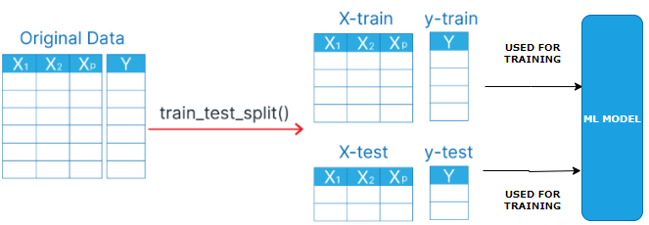

|  |
| --- |
| from sklearn.model_selection import train_test_split  x_train, x_test, y_train, y_test = train_test_split(X, y, test_size=0.2, random_state=1) |

The train_test_split method arrays or matrices into random train and test subsets.

Parameters:

* X: Features (input data).
* y: Labels (target data).
* test_size: Fraction or number of samples to use as the test set (e.g., 0.2 means 20% for testing).
* train_size: Fraction or number of samples for training (optional, usually inferred).
* random_state: Seed for random number generator (ensures reproducibility).
* shuffle: Whether to shuffle data before splitting (default is True).
* stratify: Ensures the split preserves the proportion of labels (optional, usually for classification).
* Returns: Splits the data into x_train, x_test, y_train, and y_test.

EXAMPLE

1. Import necessary Python libraries: pandas, train_test_split from sklearn.model_selection, and StandardScaler from sklearn.preprocessing.
2. Load the Iris dataset using Pandas read.csv. Dataset name is iris.csv.
3. Use train_test_split to split the dataset into an 80-20 training-test set.
4. Apply random_state with 42 value in train_test_split function for reproducible results.
5. Print X_train, X_test, Y_train, and Y_test to understand the dataset split.
6. Use StandardScaler to apply feature scaling on the training and test sets.
7. Print scaled training and test sets to verify feature scaling.

Step 6: Feature Scaling

# DATA PROCESSING USING PYTHON

# REGRESSION

* A **regression model** is a type of statistical or machine learning model used to understand the relationship between a **dependent variable** (what you're trying to predict) and one or more **independent variables** (the inputs or predictors).
* **In simple terms:** A regression model helps answer questions like:
  + "How does the price of a house depend on its size, location, and number of bedrooms?"
  + "How does advertising spending affect sales?"

Types Of Regression Models

1. Linear Regression

* Assumes a straight-line relationship between variables.
* Example: y = a + bx
* Multiple Linear Regression:
* Like linear regression, but with multiple input variables.
* Example: y = a + b*1x*1 + b*2x*2 + … + b*nx*n
* Polynomial Regression:
* Models curved relationships by including powers of the input variables.
* Example: y = a + bx + cx2
* Logistic Regression:
* Used when the output is categorical (e.g., yes/no, 0/1).
* Despite the name, it's used for classification, not regression.
* Ridge, Lasso, And Elastic Net Regression:
* Variants of linear regression that include regularization to prevent overfitting.

What It’s Used For

* Predicting future values (e.g., stock prices, sales).
* Understanding relationships between variables.
* Making data-driven decisions in business, science, and engineering.

## SIMPLE LINEAR REGRESSION

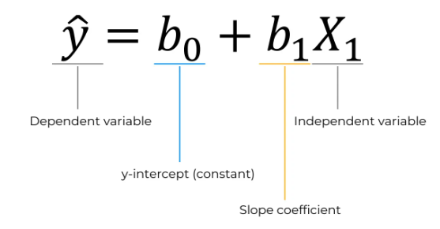

## MULTIPLE LINEAR REGRESSION

## POLYNOMIAL REGRESSION

## SUPPORT VECTOR REGRESSION

## DECISION TREE REGRESSION

## RANDOM FOREST REGRESSION